DASL UAV Antenna Gimbal

Final Report

Kalli Albright
Kaitlyn Barr
Dustin Branges
Daniel Johnson

2017-2018



Project Sponsor: Dr. Michael Shafer
Faculty Advisor: Dr. Sarah Oman

DISCLAIMER
This report was prepared by students as part of a university course requirement. While considerable effort has been put into the project, it is not the work of licensed engineers and has not undergone the extensive verification that is common in the profession. The information, data, conclusions, and content of this report should not be relied on or utilized without thorough, independent testing and verification. University faculty members may have been associated with this project as advisors, sponsors, or course instructors, but as such they are not responsible for the accuracy of results or conclusions.

EXECUTIVE SUMMARY

This report serves the purpose of documenting the progress of the design and manufacture of a gimbal for an unmanned aerial vehicle (UAV) antenna. The purpose of this project is to make the tracking of wild animals faster, easier, and more accurate. The client, Dr. Michael Shafer, through the Dynamic and Active Systems Lab (DASL), is in the progress of designing a UAV capable of carrying a directional antenna that can detect the source of very high frequency (VHF) telemetry tags on animals. However, the current design only allows for the antenna to be mounted parallel to the ground. Due to the radiation pattern of the antenna, it has been determined that more accurate data can be collected if the device was able to pitch towards the ground. This task of pitching the antenna was entrusted to team D1 of the Northern Arizona University Capstone 2017-2018 team. To successfully complete this project, the team created a gimbal device that allows the antenna to rotate up to 45°. This motion was done in one of two modes, where the user may either enter a specific desired angle, or through a constant sweeping motion. The antenna is able to confirm its angle position and relay it back to the user in real time. More specific requirements are further discussed in this report such as weight and size restraints.

Working towards the objective of the project, the team created a linkage system. This design consists of two points of connection between the UAV and antenna. The first point is towards the back of the antenna and acts solely as a sliding pin connection. This is achieved through two mounting brackets and a pivot base that attaches around the body of the antenna. The linkage towards the front of the system is the portion that controls movement. This system consists of four mounting brackets and a pivot base, however, on either side of the antenna is a rigid bar. One end of the rigid bar attaches directly to the pivot base, while the other goes through the mounting brackets. One rigid arm is connected to a horn of a small servomotor. As this motor rotates, it forces the bar to rotate respectively along with the antenna, due to the connection through the pivot base. With this design, the team is able to easily modify the achievable angle, by changing the distance between mounts, or the length of the rigid bar. The overall estimated cost of this mechanism comes in just under $200, well within the $500 dollar budget for the team. This margin allowed the team the potential to buy a lighter weight, more efficient motor, create more prototypes for testing, and provide the client with spare parts.

The manufacture of the design described above was implemented through several phases of prototyping, followed by extensive testing. During assembly, many problems were encountered which resulted in a corresponding design change. All testing was first conducted on the ground to ensure no malfunctions cause damage to the client’s pre-existing UAV. After the device was proven to work successfully on the ground, the team may attach it to the UAV for field testing. A detailed schedule of implementation as well as a detailed description of design alterations during the manufacture has also been included in this report.

Table of Contents
DISCLAIMER i
EXECUTIVE SUMMARY ii
1 BACKGROUND 1
1.1 Introduction 1
1.2 Project Description 1
2 REQUIREMENTS 2
2.1 Customer Requirements (CRs) 2
2.1.1 Simple 2
2.1.2 Modular 2
2.1.3 Multiple modes of movement 2
2.1.4 Relay angle to user 2
2.1.5 Maintainable 2
2.2 Engineering Requirements (ERs) 3
2.2.1 Rotational Range 3
2.2.2 Modes 3
2.2.3 Serial communication 3
2.2.4 Surface Area 3
2.2.5 Weight 4
2.2.6 Voltage 4
2.2.7 Cost 4
2.2.8 Part Installation Time 4
2.2.9 Number of Tools 4
2.2.10 Linkages 4
2.3 Testing Procedures (TPs) 4
2.3.1 Rotational Range 4
2.3.2 Modes of Rotation 5
2.3.3 Serial Communication 5
2.3.4 Surface Area 5
2.3.5 Weight 5
2.3.6 Voltage 5
2.3.7 Cost 5
2.3.8 Part Installation Time 5
2.3.9 Number of Tools 5
2.3.10 Linkages 5
2.4 House of Quality (HoQ) 6
3 EXISTING DESIGNS 7
3.1 Design Research 7
3.2 System Level 8
3.2.1 Existing Design #1: MOOG Antenna Pointing Mechanism 8
3.2.2 Existing Design #2: Octopus UAV Tracking Antenna 8
3.2.3 Existing Design #3: Marcus UAV Retractable Gimbal 9
3.3 Functional Decomposition 10
3.3.1 Black Box Model 10
3.3.2 Functional Model 10
3.4 Subsystem Level 11
3.4.1 Subsystem #1: Control System 12
3.4.2 Subsystem #2: Motor 12
3.4.3 Subsystem #3: Frame/Mount 12
4 DESIGNS CONSIDERED 14
4.1 Design #1: Plate with Motor 14
4.2 Design #2: Motor with Lead Screw 14
4.3 Design #3: Pulley System 14
4.4 Design #4: Linkage System 15
4.5 Design #5: Hydraulic Piston 15
4.6 Design #6: Two Motors 16
4.7 Design #7: Centered Pulley 16
4.8 Design #8: Single High Torque Motor 16
4.9 Design #9: Two Hydraulic Pistons 17
4.10 Design #10: Stirling Engine 17
5 DESIGN SELECTED 18
5.1 Design Selection 18
5.1.1 Original Design Selection 18
5.1.2 Current Design Selection 18
5.2 Design Description 19
6 PROPOSED DESIGN – First Semester 20
7 IMPLEMENTATION – Second Semester 22
7.1 Manufacturing 22
7.2 Design Changes 22
7.2.1 First Iteration 22
7.2.2 Second Iteration 23
7.2.3 Final Iteration 25
8 TESTING 27
8.1 Testing Overview 27
8.1.1 Rotational Range 27
Figure 25: Rotational Range 27
8.1.2 Modes of Rotation 27
8.1.3 Serial Communication 27
8.1.4 Surface Area 28
8.1.5 Gimbal Weight 28
8.1.6 Voltage 29
8.1.7 Cost 30
8.1.8 Part Installation Time 30
8.1.9 Number of Tools 30
8.1.10 Linkages 30
8.2 Summary of Testing 31
9 Conclusions 31
9.1 Contributors to Success 31
9.2 Opportunities/areas for improvement 32
10 REFERENCES 34
11 APPENDICES 36
11.1 Appendix A: Semester 1 Proposed Design Drawings 36
11.2 Appendix B: Second Semester Schedule 39
11.3 Appendix C: Final Design Budget 40
11.5 Appendix D: Final Design Part Drawings 41
11.6 Appendix E: Size Testing 44
11.7 Appendix F: Weight Testing 46

BACKGROUND

Introduction
Animals of every major group migrate such as mammals, reptiles, birds, etc. To better understand the lives and traits of these animals, scientists track their migration pattern. Wildlife is tracked using Very High Frequency (VHF) telemetry tags. Traditionally, humans spend hours in nature triangulating signals coming from the tags on the wildlife. This process can be both time consuming and strenuous. The Dynamic and Active Systems Lab (DASL), led by Dr. Michael Shafer is currently developing an Unmanned Aerial Vehicle (UAV) with a Telonics RA-23K VHF antenna, to make the tracking of wildlife easier and more efficient. Rather than humans tracking through forests, a UAV can fly above the forest canopy to locate the source of a signal. However, the antenna is not able to properly receive data if a tag is below the UAV and therefore not within the radiation pattern. Therefore, the D1 Capstone team was tasked with creating a gimbal system for the user to control the angle of the antenna while the drone is in flight. The system is also able to report the angle of the antenna back to the user to ensure accurate and reliable data. The goal of this project was to make the collection of data faster, therefore allowing the user to be more productive in the tracking of animals. This system is of interest to the DASL because the ability to angle and rotate the antenna will remove the need for the UAV to pitch, ultimately making flight more stable. By creating a system that can pitch the antenna while the UAV remains stable allows the user to receive more accurate data on the location of tags. Overall this assists in resolving ecological research paradigms, as wildlife tracking will be fast and efficient. The next section will further describe the project.

Project Description
The following is the original project description provided by the sponsor:

“The Dynamic and Active Systems Lab is currently developing an unmanned aerial vehicle for use in tracking small wildlife using VHF radio beacon tags. The project team would like to be able to move the VHF receiving antenna on the UAV in flight. Students on this project will build a gimbal system that can rotate an antennal about a single axis continually or to a specified angle. Communication will be maintained to a flight computer, which will send commands and receive angle position information from the subsystem. Detailed requirements regarding size, weight, power, communication, etc. will be determined in the early stages of the project. The ideal team would consist of two mechanical and two electrical engineering students.” [1].

Since receiving this description, the only thing that differed is the team composition. The team consists of four mechanical engineers. Additional details have been specified by meetings with the client, which will be discussed in the next chapter of the report.

REQUIREMENTS
This chapter will discuss the requirements of the project including customer requirements and engineering requirements. These were weighted against each other in the House of Quality to determine the how crucial each requirement is. The chapter begins with the customer requirements explained in Section 2.1.

Customer Requirements (CRs)
Here the customer needs and their related importance to the project are discussed. After gathering notes from the first meeting with the client, the team formulated five needs they deemed necessary for the project. These needs included a simple, modular design, which has multiple modes of movement and can relay the angle to the user. The design should also be maintainable, as it is exposed to a high potential for damage. Each customer need is ranked on a scale from 1-5 based on what the team believed to be the most important. Each need is described thoroughly in the following subsections.

Simple
Simplicity was one of the main needs stressed by the client. It is important to have a device, which works well rather than a complicated design that fails to complete the desired task. To achieve simplicity, the device used as few linkages as possible. On top of this, there are as few total components as possible, such as screws, bolts, plates, etc. This ensured low cost and success in the field. The team ranked this need as a 4/5 due to the client’s insistence on a well-done and simple project rather than an incomplete and complex design.

Modular
The second customer need was that the device fits on a pre-existing modular housing for the UAV. Each part shall be easily integrated with the pre-existing UAV design, ensuring the success of each flight. The modular design was important, but the team had flexibility in how their device could be mounted, so the modular design was ranked as 3/5 for importance of the customer need.

Multiple modes of movement
Another customer request was that the device moves in multiple modes. One mode is manual, controlled from the ground, in minimum desired intervals. The other mode is automatic. The operator is able to enable an automatic mode and have the gimbal move the antenna continuously on a predetermined path. Although the sweep mode would be beneficial to the client, no emphasis was directly placed on this topic; therefore it was only ranked as 2/5 for customer needs.

Relay angle to user
The most crucial customer need was that the angle of the antenna may be communicated to the client. This information is accurate and easy to read. This requirement was crucial to the customer, because without knowing the exact angle of pitch for the antenna, the data looses accuracy and becomes meaningless. Failing to meet this need would render the project a failure; therefore it was ranked as 5/5 for importance.

Maintainable
The last customer requirement was for the device to be made with easily maintainable parts. When necessary the parts are replaceable with off the shelf parts, which are easily obtainable, or with spare parts provided by the team. When possible, 3D printing will enable recreation of parts for lower cost and ease of manufacturability. All part files were maintained for future production. The maintainability of the device was also crucial to the project, as the device is mounted on the bottom of a drone and has the most potential for damage if a fall occurs. This means the device is easy to manage and maintain, even in the field. This led the team to rank the need as 4/5.

Overall, the team's objective was to deliver a simple, maintainable, and modular antenna gimbal with the capability to move in multiple modes while conveying the exact angle back to the user. Engineering requirements developed based on these customer requirements will be discussed in the next section.

Engineering Requirements (ERs)
This section discusses the nine engineer requirements provided by the client, and further developed by the team. Each of the requirements, listed in Table 1, must be met in order for the device to successfully fulfill the project objectives. If one requirement was not met, the device becomes useless to the customer.

Table 1: Engineering Requirements for Antenna Gimbal
Requirement | Target
Rotational Range | $≥$45$°$
Modes | $≥$2
Communication | 9600 bit/s
Surface Area | $≤$15 in.²
Weight | $≤$0.5 lbs
Voltage | $≤$5 V
Cost | $≤$$500
Installation Time | $≤$60 min.
Number of Tools | $≤$3
Linkages | $≤$4

Each of the requirements shown in Table 1, are further explained in the following subsections.

Rotational Range
The gimbal allows for no less than 45° of travel below the horizontal axis. If possible the client preferred the gimbal to be able to travel to 90° below the horizontal axis, but it was not critical to success. The team strived to meet desired qualities, after successfully completing stated requirements.

Modes
The gimbal shall operate in a minimum of two modes including a sweeping mode and holding at a specific angle.

Serial communication
The existing UAV is controlled through a Raspberry Pi computer. To be able to integrate the gimbal into the onboard flight controller, an Arduino microcontroller is used to control the gimbal. The Arduino system is able to communicate at a 9600 Baud rate via USB to the onboard Raspberry Pi. Without this communication, the user would not be able to control the gimbal angle or know the precise angle of the antenna. The Baud rate is measured using an oscilloscope, which the team had access to through the DASL.

Surface Area
The external dimensions of the gimbal were defined by the existing modular design of the drone. For the gimbal to be used, it fits within the allotted space of the modular UAV housing. This means, the design adheres to an octagonal plate with total surface area of 15 in.²

Weight
Due to the maximum payload the UAV can carry, the gimbal attachment can not exceed 0.5 lbs. Idealistically, the team created a gimbal even lighter, which allows for longer sustained flight of the UAV.

Voltage
The gimbal and controller must operate off the UAV’s own power supply. The team was allotted 5 V to run the gimbal system after all necessary flight component power consumptions are accounted for. To test the power the team used a digital multimeter, which they also had access to through the DASL.

Cost
For this project, the team was given an ideal budget of no greater than $500.00. However, if allowable circumstances arise, the client was willing to provide funding up to $1,000.00.

Part Installation Time
Given the modular design of the UAV, the gimbal could either be installed or removed in no more than 60 min with a ±10 min tolerance. This ensured that the device was maintainable in the field in the case of a crash or other failure.

Number of Tools
The gimbal must be maintainable. To meet this requirement, the final device must be able to be fully assembled and disassembled using no more that three tools, as the client will not have access to a large tool box in the field.

Linkages
In order to maintain a simple design, the system contains less than four linkages for movement of gimbal. This requirement also kept the design maintainable, as there are fewer components to repair in the case of an accident in the field.

Testing Procedures (TPs)
This section outlines testing procedures to verify all engineering requirements were met by the system. The majority of the tests are either pass or fail, with no room for tolerances. Each test is described in the following subsections.

Rotational Range
The angle of travel must to go from 0° (horizontal) to 45° below horizontal. This was tested within the modular plates of the UAV to ensure correct angles are achieved. It was measured using the angle reported by the system and approximated with a protractor and by eye to ensure a correct reading from the system.

Modes of Rotation
The device was tested for both stepping modes and continuous motion. This was performed with the motor outside of the assembly. The team ran a program, telling the motor to go to either move to a specific angle, or continuously sweep from 0° to 45°. The motor was then installed into the system and tested with all components to ensure correct function inside the UAV assembly.

Serial Communication
To allow communication between the Arduino Pro Mini, which controls the antenna assembly, and the Raspberry Pi, which acts as the UAV onboard flight controller, the system must operate at the same baud rate. The team was given a specified baud rate of 9600 that should allow the Arduino Pro Mini and Raspberry Pi to communicate. To test against this, the team ran a code, which displayed the actual operating baud rate of the Arduino Pro Mini.

Surface Area
The overall surface area of the system mounting to the UAV is less than 15 in². This requirement was tested by measuring the surface area of the system that attaches directly to the UAV, such as the top of the mounts. This area is measured with a ruler and calculated using the geometry of the shape of the mounts.

Weight
To test the weight requirement, the system was weighed with a postal scale or other high accuracy scale provided by the DASL. The total mass of the device must be within the allotted mass of 0.5 lbs.

Voltage
The UAV is capable of providing the device 5V during flight. The power input test was conducted using a digital multimeter (DMM) to measure the voltage supply from the UAV to ensure the correct voltage was being supplied to the Arduino Pro Mini.

Cost
All costs for components and services did not exceed the budget of $500. This requirement was tested by adding the total cost of components for the gimbal system.

Part Installation Time
The installation of the system could take no more than one hour. The team conducted multiple trials of replacing the entire system. This was done using a timer found on any iPhone with a resolution of 0.01s. The team chose to replace the entire system for this test as the worst case scenario is for all components to break and replacing the entire system compared to a portion of it would take the maximum amount of time. Since entire system can be replaced in less than one hour, then any part of the system can be replaced in less than one hour. To obtain an average, this test was conducted three times.

Number of Tools
To test the number of tools required for the system the team fully assembled and disassembled the system and counted the number of tools required.

Linkages
The total number of moving components could not exceed four. This requirement was tested by counting the number of linkages present in the design. There were no special tools or equipment required to measure this specification.

House of Quality (HoQ)
This section discusses the House of Quality, Table 2, for the antenna gimbal. The team first compared customer needs described in Section 2.2 with the engineering requirements in Section 2.3, in the center of the House of Quality. For needs and requirements having no correlation, the cell is left blank. Little, moderate, and strong relationship is marked as a 1, 3, and 9 respectively. The team repeated this process in the top of the House of Quality, this time relating engineering requirements to other engineering requirements to determine the importance of their relationships. Using the weightings of the customer needs and strength of relationship to the engineering requirements, the team was able to formulate an absolute technical importance for each engineering requirement, then rank them in the relative technical requirement row. Through this process, the team found that part installation time, rotational range, and the number of linkages were the highest-ranking technical requirements for the project. Since these requirements had such a large relation to the customer needs along with other engineering requirements, they were strongly considered in the designing of the device. Lastly the House of Quality compared customer needs to pre-existing designs, including the MOOG [6], Octopus [7], and Marcus UAV [8] gimbal. These pre-existing designs are discussed further in Chapter 3 of this document.

Table 2: House of Quality for Antenna Gimbal
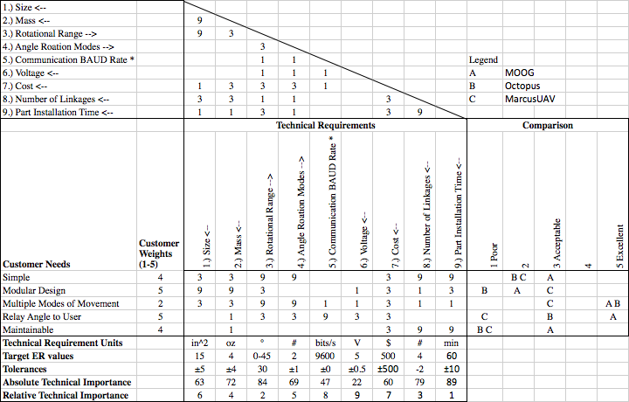

EXISTING DESIGNS
This chapter discusses the approaches to designing the antenna gimbal system. Sources used for research include article databases and pre-existing design websites. In addition to researching pre-existing designs, this chapter includes the functional decomposition including the black box and functional models. Lastly the team researched the subsystems required for their project and researched existing designs at each subsystem level.

Design Research
Prior to design research, the team first needed a basic understanding in VHF telemetry tracking. It was determined that “to locate an animal using VHF radio tracking, scientists must be close enough to the animal with the radio antenna so they can pick up the signal from the radio transmitter on the animal” [2]. Once a signal is located, the scientists and researchers are able to follow the direction from which the signal is the strongest in order to locate the animal. This is traditionally done on foot, which can be painstaking and time consuming. Some scientists take to cars or planes to reach the signal faster. With this information, the benefit of being able to track wildlife using a UAV became more apparent. The UAV could cut out the time for tracking on foot, the accessibility cars and trucks might not be able to reach, and the cost of renting an airplane. However, after further research on the reception radiation pattern for VHF, pertaining especially to the RA-23K VHF Antenna used by the DASL lab, the team also saw the need for a rotating antenna. As seen in Figure 1, the RA-23K antenna receives radiation patterns on a horizontal plane, with more information incoming to the front of the antenna compared to the back. The ability to pitch the antenna using a gimbal on the UAV allows for a larger range of reception and higher data collection and accuracy, especially if the signal is coming from below the UAV.

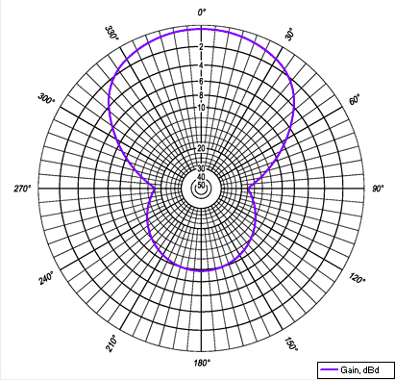
Figure 1: RA-23K Reception Radiation Pattern [3]

After basic research on VHF telemetry tracking, the team looked into existing designs. Using the engineering database, Compendex, the team found that using UAVs to track wildlife is an ongoing development. Other researchers have also reported “the use of small unmanned aircraft systems (UAS) for wildlife tracking offer many advantages such as cost reduction, human effort reduction and data acquisition efficiency due to the usage flexibility offered by the system in comparison to conventional methods” [4]. This article described the use of acoustic telemetry to track wildlife using a small UAV. This varied from the team's project as the RA-23K antenna reads VHF and requires a pitch angle. Another team was able to use a commercial radio controlled model aircraft to locate fish tags placed both on land and underwater [5]. While these reports showed the real life applications of using UAVs in tracking wildlife, they did not focus on the rotation of the antenna, so the team began searching the web for antenna pointing mechanisms to help formulate ideas and concepts they might incorporate into their own device. Upon this search, the team found a large range of designs including the MOOG Antenna Pointing Mechanism, Octopus UAV Tracking Antenna, and Marcus UAV Retractable Gimbal. Each of these designs are further described next in the system level section of the report.

System Level
This section discusses existing designs that address similar requirements relevant to the DASL UAV Antenna project. The three designs found each have desirable qualities for the team’s project, however, they also all have features that would not be compatible with the DASL UAV, which will be explained in each subsection.

Existing Design #1: MOOG Antenna Pointing Mechanism
The MOOG Antenna Pointing Mechanism [6], Figure 2, is a small device commonly mounted on spacecraft. It meets many of the requirements needed for the DASL UAV gimbal antenna. This mechanism is able to rotate in two directions and in multiple modes to relay information back to the user. However, this product does not meet the low cost need nor is it maintainable, making it impractical for this design. However, this does provide the team with one example of allowing two directional rotation, which was not a critical requirement, but desired by the client.
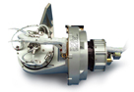
Figure 2: MOOG Antenna Pointing Mechanism [6]

Existing Design #2: Octopus UAV Tracking Antenna
The Octopus Tracking Antenna [7], Figure 3, is used on the ground to track UAVs in the air, but could have potentially been used to mount to a UAV and track other signals. The advantage of this tracking antenna is that it can be switched between a directional and omni antenna. It also has an integrated pointed algorithm that automatically points towards the direction of the strongest signal. This would be very useful while tracking wildlife, especially if the team’s system is able to relay the exact angle to the user. Rather than the user inputting multiple angles and trying to find the strongest signal, the antenna would automatically sweep for the strongest signal and point towards it. This angle would then be reported back for quick and accurate data collection. The limiting factor to this existing design is the weight, which would not be feasible on a UAV.
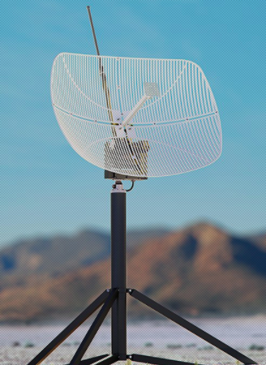
Figure 3: Octopus UAV Tracking Antenna [7]

Existing Design #3: Marcus UAV Retractable Gimbal
The Marcus UAV Retractable Gimbal [8], Figure 4, is a 2 direction rotational gimbal mounted to a UAV. However, instead of mounting an antenna to the gimbal, they use it for a camera. This gimbal still meets several requirements such as multiple modes of movement, lightweight, and full range rotation. The full range of movement comes from the fact that the camera is embedded in the system rather than sticking out like an antenna. However, the team can use this design to further formulate encapsulating designs for the antenna gimbal.
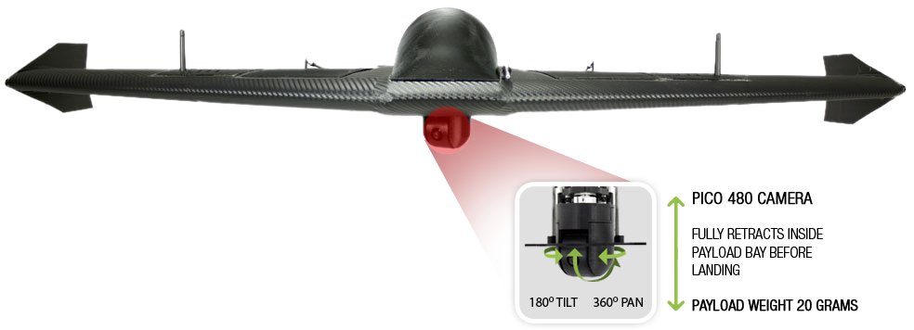
Figure 4: Marcus UAV Retractable Gimbal [8]

Functional Decomposition
In this section, the functional decomposition is analyzed in two parts. First, the black box simplifies the total function of the gimbal system and categorizes the inputs and outputs by material, energy, and signal. The main function of the system is moving the antenna at the request of the user. The action of the system will be further broken down in the functional model by each step that is performed and the individual input and output.

Black Box Model
The Black Box model allows for an easier understanding of what the device needs to accomplish. This is done by simplifying the design down to the basic inputs and outputs, specifically materials, energy, and signal. This allowed the design team to focus on the core elements and ensure that the device successfully addresses the needs of the client.

The Black Box model, as seen in Figure 5, shows all materials that enter and exit the system, meaning no material stays in the system. The input for the Black Box are electric energy as well as human energy and the outputs are heat and sound. Lastly, a signal to move the antenna is sent and a signal exits the box indicating the relative position of the antenna to the drone.

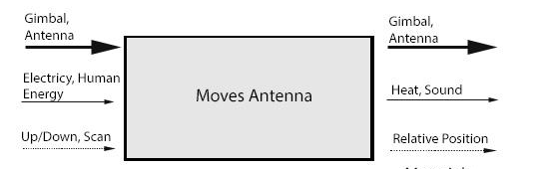

Figure 5: Black Box Model

The next section further analyzes the action of moving the antenna seen in the black box model and fully breaks it down into a functional model.

Functional Model
The section describes the functional model for the antenna gimbal. The functional model is a breakdown of how the team theorized the gimbal system would work. This is derived from the black box model by analyzing the material, energy, and signal imports and exports. The gimbal system takes in electricity from the UAV and human energy from hands controlling the remote and transmits it to rotational movement of the antenna and data back to the user. This process can be visualized in steps in Figure 6.1 and 6.2, which demonstrate a Hypothesized and Actual Functional Model respectively. Through this model, the team can visualize that their critical actions of regulating the angle, receiving VHF signal, and reporting that data back to the user all rely on electricity to run the operations while in the air. From this model, it is apparent that the functionality of the device is critical for being able to meet requirements for electric usage as described in the engineering requirements, in order for any of the main operations to take place.
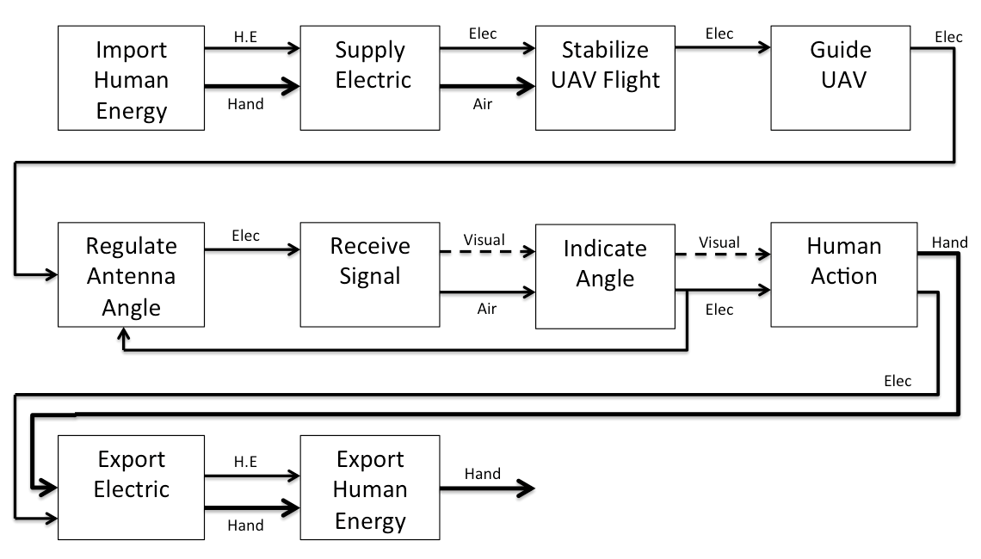
Figure 6.1: Hypothetical Functional Model for Gimbal Antenna

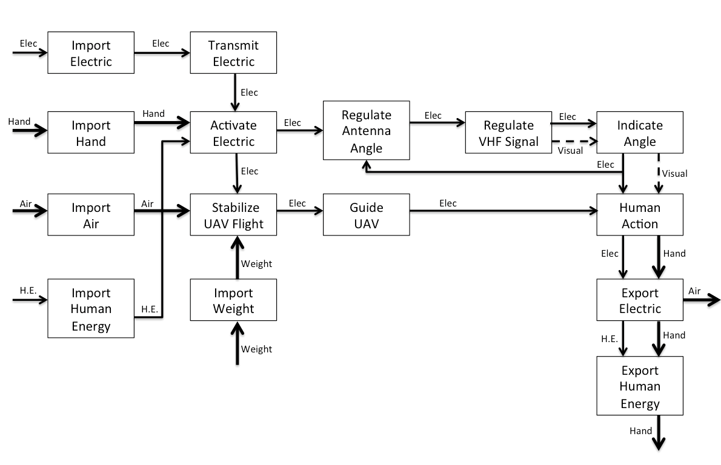
Figure 6.2: Actual Functional Model for Gimbal Antenna

Subsystem Level
This section will discuss the different subsystems used to make an antenna gimbal. Currently, gimbals and their controllers are typically applied to stabilize video recording. While incorporating a gimbal to control a VHF antenna is a fairly unique idea, the overall system and controllers can be applied to either situation. The antenna gimbal system was broken into three subsystems including the control system, motor, and frame/mount. Each of these subsystems are further described in the following subsections along with existing designs for each.

Subsystem #1: Control System
The control subsystem was important in the design of the antenna gimbal because it enables the control of the angle and readout. This device is used to take information from the on board computer and output angles, then relay that information back to the on board computer for communication to the ground.

Existing Design #1: Arduino
The Arduino is the industry standard in terms of small microcontrollers. This microcontroller has a large amount of user support due to it being so ubiquitous [8]. An advantage to this control system was there were many forums of existing code the team used to their advantage in programming.

Existing Design #2: MSP430 LaunchPad
The MSP430 LaunchPad is a lightweight microcontroller. Where this device differs from the Arduino is in its lower power consumption, weight, and cost. This device costs $4.30 which is about half that of an Arduino unit [9].

Existing Design #3: Teensy 2.0
The Teensy 2.0 is by far the smallest microcontroller. It comes in at about the size of a quarter and has the capability of running Arduino programs and sketches. This device is great for projects that are constricted on weight and or space while needing to run Arduino code [9]. The size of this system would be beneficial in fitting to the small modular design for the team.

Subsystem #2: Motor
This component of the gimbal was imperative to hit the requirements laid out for the team. These motors hold a certain amount of torque at a steady angle under flight power, while maintaining a lightweight requirement. This device is also repeatable to maintain accuracy.

Existing Design #1: Short Range Servo Motor
This design has the capability to be finely controlled. While it is a stepper motor it has the capability to be put into an orientation and then hold that orientation. They are highly efficient and are great for applications where vibration is an important consideration [10].

Existing Design #2: Goteck Metal Gear Micro Servo
This micro servo is designed to be used in lightweight flying machines. It has a high stall torque, which would be helpful while maintaining a slim and lightweight design. This servo can run off standard flight batteries and has low power consumption [11].

Existing Design #3: DSM 44
This servomotor is designed specifically with RC control in mind. It is both small and lightweight, runs off standard 5-volt supplies and has a high torque output for its size [12].

Subsystem #3: Frame/Mount
This part of the device is important to maintain a rigid platform for the antenna to gimbal from. It is structurally strong, while being lightweight, and capable of being attached to the UAV via the modular design plates provided.

Existing Design #1: Channel Master 3079 Antenna Mount
This antenna mount is a very basic design made from conventional materials. It is readily available and cheap to purchase. At over half a pound it was not right for our applications but was considered [13].

Existing Design #2: Panel-Hanging Bracket from McMaster-Carr
This off the shelf bracket is extremely accessible and cost effective. Made from stainless steel it is corrosion resistant and easy to maintain. It is heavy for its weight but overall may be a decent choice. This would be modified in house to match our modular design for easy of assembly in the field [14].

Existing Design #3: Generic L-bracket
Using this design is very similar to the use of the off the shelf bracket from McMaster-Carr but offers easier obtainability with a lighter weight design. Again it would be made to fit our modular design with some slight modification keeping cost down [15].

DESIGNS CONSIDERED
Chapter four will serve the purpose of describing the designs for the DASL UAV Antenna Gimbal as brainstormed by the team. The team formed ten ideas ranging in capability, feasibility and simplicity. Each of the designs are described as follows and displayed in Figures 7-16.

Design #1: Plate with Motor
In Design 1, Figure 7, the antenna is mounted through a plate, which is controlled by a motor. Two brackets fastened to the octagonal UAV housing support the plate. As the motor rotates, the plate and antenna rotate as well. The advantage of this system was simplicity as it only contains four components not including the antenna. It can be made low cost and is easily maintainable. The disadvantage of this design was the need for a high torque motor that would still be lightweight. Another downside was a limited range of movement.
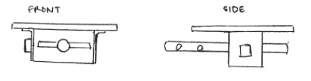
Figure 7: Plate with Motor

Design #2: Motor with Lead Screw
In this design, a lead screw drives the back end of the antenna to control the angle of attack. As seen in Figure 8, the antenna is pinned near its center to the base of the UAV. The lead screw is mounted above one end allowing it to push the antenna down to a desired angle. In this system, the linear movement must be converted into rotational measurements to relay the exact angle to the client. The advantage of this design was simplicity and lightweight mechanisms; however, the downfall was that the lead screw would always be sticking out during flight and offer a limited range of motion.
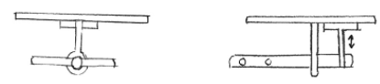
Figure 8: Motor with Lead Screw

Design #3: Pulley System
This system used a simple cord attached to the antenna. The motor draws in the cord onto a spool while retracting the antenna upward towards the base of the UAV. This system would also consist of a potentiometer to determine the angle, which the antenna is resting at. An advantage of this design was that the sweep mode would be easily incorporated with a constant rpm of the motor. Issues include the cord, which is not rigid, could cause the antenna to move with turbulence of the UAV.
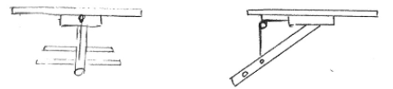
Figure 9: Pulley System

Design #4: Linkage System
This system used a linkage to drive the angle of attack, Figure 10. The motor is attached to the linkage and that drives the antenna. The linkage cams a boss on the antenna mount to move the angle up or down. The advantage to this design was that all mechanical operation can be seen and problems can be diagnosed quickly. The main disadvantage was the amount of torque required to power the cam and measuring the angle of attack.
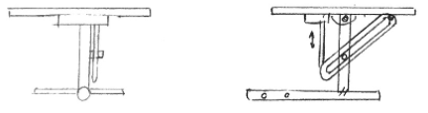
Figure 10: Linkage System

Design #5: Hydraulic Piston
This was a similar design to the lead screw but with a self contained hydraulic unit, Figure 11. The system incorporates a pump, reservoir, and piston system. This unfortunately added both weight and complexity. However the design has the advantage of being much more self-contained when compared to the lead screw as there are no parts that extend beyond the antenna when retracted.
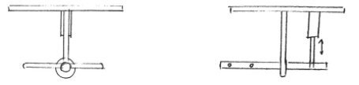
Figure 11: Hydraulic Piston

Design #6: Two Motors
Design 6 is similar to Design 1 in the way it rotates the antenna. In this system, rather than the antenna being directly attached to the rotating plate, another motor is first fastened to the plate, then the antenna is connected to the second motor. This allows the system to have two degrees of freedom, which the client showed interest in. Unfortunately the motor rotations would interfere with each other and this would be kept in mind during dimensioning and designing of the system.
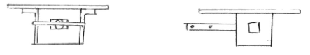
Figure 12: Two Motors

Design #7: Centered Pulley
This design, as seen in Figure 13, mostly mimics that of Design 3, however in an effort to maintain the same center of gravity as the original UAV, the mounting location for the antenna is offset towards of the edge of the UAV with the motor and microcontroller located in a more central position. The disadvantage of this design is again a lack of rigidity as the cable allows for fluctuation of the antenna during flight.
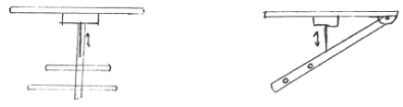
Figure 13: Centered Pulley

Design #8: Single High Torque Motor
Design 8, as seen in Figure 14, works by attaching a high torque motor in a 1:1 ratio, directly to the antenna. This design offers for a more simplistic design, however requires the use of a rotary encoder, or resolver, to track the orientation of the antenna. While the weight of the motor in this design may be high, it is the only mass of the component. This design does not account for the length of the antenna and therefore would most likely have interference issues.
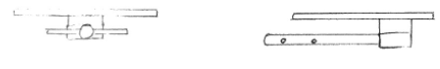
Figure 14: Single High Torque Motor

Design #9: Two Hydraulic Pistons
Similar to Design 5, this concept involves two hydraulic pistons. There is one attached closer to the front of the antenna and another towards the back. They work in unison (one retracts as the other extends), to cause the antenna to pivot. This would allow the pistons to be smaller compared to the single piston design. A disadvantage of this design is that the UAV needs to house a pump and water reservoir to allow the pistons to function and therefore adding unnecessary amounts of weight to the system.
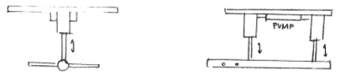
Figure 15: Two hydraulic Pistons

Design #10: Stirling Engine
Design 10 incorporates a stirling engine into the system as seen in Figure 16. This mechanism moves based on a heat differential. A constant difference in temperature allows for continuous movement of the antenna. However, there is not a simple way to control the exact angle of the antenna, leading to inconsistent data.
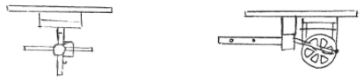
Figure 16: Stirling Engine

DESIGN SELECTED
Chapter 5 serves the purpose of explaining the rationale for the design selected by the team.

Design Selection
This section explains the rationale of the selection of a design for the UAV antenna gimbal. The design was carefully selected after evaluations of the designs using a decision matrix and through meetings with the client as described in the following subsections.

Original Design Selection
To help the team form a rational decision for one of the ten designs described in Chapter 4, they formed a decision matrix, seen in Table 3. The team decided upon five criteria from both customer needs and engineering requirements. The first and most important criterion is the weight of the system. If the device cannot be lifted by the UAV, it is not a viable design. The second most important criterion is the ability to relay an accurate angle of the antenna to the user. Without this piece, the device would not provide accurate data and would be pointless. Third most important is maintainability. Since the UAV is at risk of crashing, and the antenna gimbal is attached to the bottom, it is important that the system be maintainable so that it can continue functioning and collecting data for the user. The team also determined the angle range and position to be important, as the device allows ample rotation to gather quality data, as well as hold the angle in position rather than letting it bounce or hang freely. Lastly, the team considered cost. This requirement was not as high of a concern as the budget was loose, however, the team planned on sticking to the desired budget of under $500, so cost was still taken into consideration. To evaluate the designs, the team first picked four of what they thought to be the most viable designs. They then scored each design on a scale of 1-10 for each criterion and applied the weight. Through this process, the team found Design 1: Plate with Motor, to be the best option. This design met all customer needs of simple, maintainable, modular, able to relay an angle, and able to have multiple modes of movement. It also met each of the engineering requirements, which ensured a more careful designing of the idea. Therefore, this was the first design the team chose, but was subject to change as seen in the next section.

Table 3: Decision Matrix
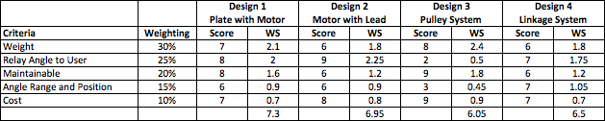

Current Design Selection
After utilizing the decision matrix to select Design 1, the team presented a prototype of the design to the client, Dr. Michael Shafer. He then expressed concern for the structural stability of Design 1, as the mounts that would attach the gimbal to the UAV would be long and thin, making it more prone to breaking upon impact. After looking at the proposed prototype, the client expressed an interest for the design to be able to operate using short mounts so that it fits between two modular plates, rather than just on the bottom of the last plate as discussed in the initial scope of the project. To accommodate for the decrease in space allotted, the client allowed for a smaller rotation and asked for a minimum of a 45 degree angle rather than 60 degrees. Dr. Shafer also recommended that the team have two points of contact between the antenna and the UAV rather than one, as seen in Design 1. After reviewing the team’s other design options, he preferred the idea of a linkage system as proposed in Design 4, which ranked third in the decision matrix. From these new points of consideration, the team created a new design, extenuating from Design 4, which will be described in the next section.

Design Description
After a meeting with the client, several concerns were uncovered with the team's original design. To resolve problems with the original design, as well as to incorporate new requests from the client, the team formed a linkage concept, depicted in Figure 17. As seen in the figure, this design allowed for two points of connection between the antenna and UAV, as desired by the customer. At the back end of the antenna, there is a simple pin connection allowing pure rotation. Towards the front end there is a linkage arm attached to a clamp around the antenna. As the arm is pitched up or down by a small motor, the antenna will also rotate to the desired angle input by the user. Exact measurements can be viewed in Appendix A Figures A1-A6. Overall, this new concept is more compact, secure, and cost effective than previously discussed designs.

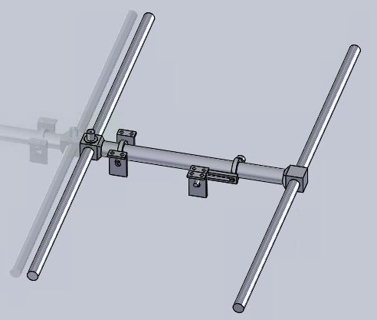
Figure 17: Current Antenna Gimbal Design

PROPOSED DESIGN – First Semester
This section discusses the implementation and fabrication of the antenna gimbal. After selecting the design discussed in section 5.2, the team chose to 3D print a prototype for a proof of concept. Through this prototype, they found that the mounts connecting the antenna to the UAV do not allow full rotation of the pivot base, as it interfered with the housing. From this prototype, the team expanded the length of the mounts to create a fully moveable system. The team continued to print prototypes with their personal 3D printers to ensure problems such as this can be avoided before the final fabrication of the system. Initial prototypes are printed using PLA. Final prototypes and the final system were printed using ABS, which can be smoothed with acetone for better tolerances and fits. The use of 3D printing reduced the emphasis on tolerancing, as the parts produced will carry the same tolerances, this does not however reduce the necessity of clearances, which were included in the design. The team chose to keep the final design manufactured through 3D printing, to keep the system easily maintainable for the client in case of part failure during a strong impact. Through the use of 3D printing, the client only needs the part files and use of a 3D printer which can be accessed several places on the Northern Arizona University campus. After finishing prototyping, the team mocked up the system, working towards full integration. In this phase, the team worked to create a fully functioning system as depicted in Figures 18 and 19. The mock up of the design allowed the team to still adjust for improvements.
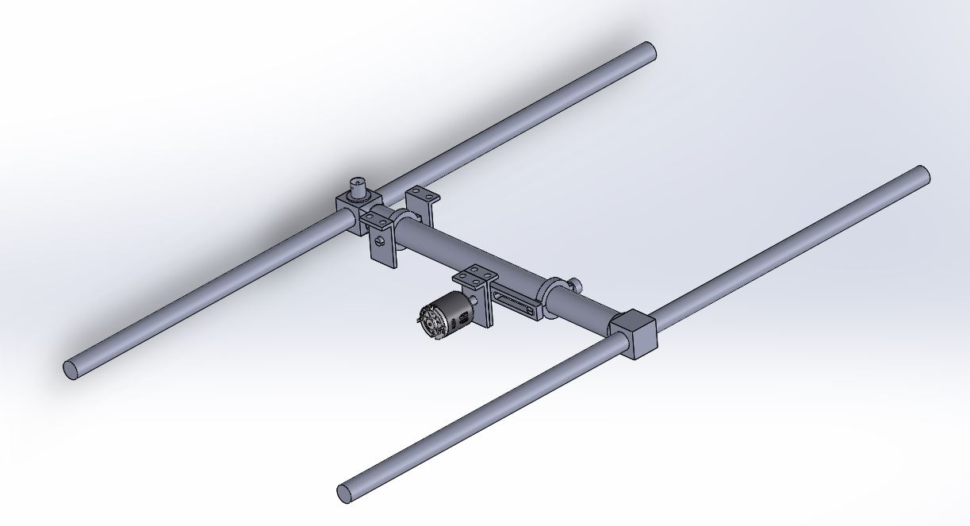
Figure 18: Design Assembly View

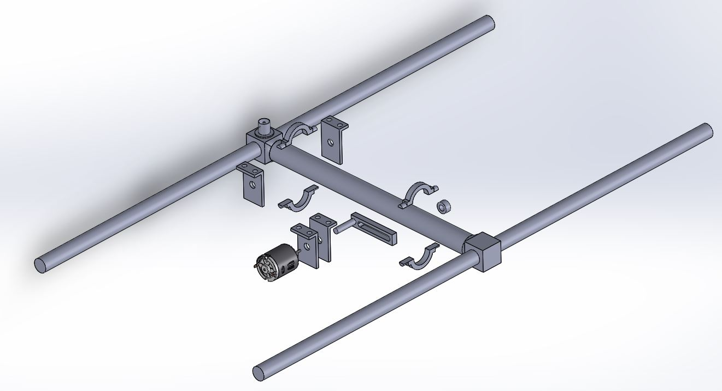
Figure 19: Design Exploded View
With a basic setup of the system, the team was able to implement a program to run the motor and test the abilities of the device (e.g. range of motion, lifting capabilities, sweeping features, etc.). Resources needed for this testing included a postal scale and Raspberry Pi, which attaches to the Arduino. Each of these is found in the DASL. The system was then tested thoroughly on the ground. At this stage, modifications to better integrate the program, motor, and physical system, would be done before a final device is fabricated. Once proved to be fully operational on the ground, the team then attached the system to the UAV and ensured that it would work as expected in the field. DASL can fly different courses, in different orientations, and different settings to double-check that no errors occur. Errors occurring during this phase of testing were troubleshot immediately and replacement parts produced quickly. The overall schedule for these implementation tasks are displayed in Appendix B, Figures B1 and B2. The resources required for the antenna gimbal are listed in Table 4, along with their corresponding costs. Materials for the system were purchased online from SparkFun [16] and McMaster-Carr [14] and Amazon. The main source of cost came from the stepper motor, motor driver, and other electrical components such as the FTDI cable, real time clock, and open log. The team was willing to spend a significant amount on the motor, as it needs to be able to provide enough torque to pivot the antenna, as well as be light enough in weight to satisfy the 0.5 lb weight restriction.

Table 4: Proposed Design Bill of Materials and Budget
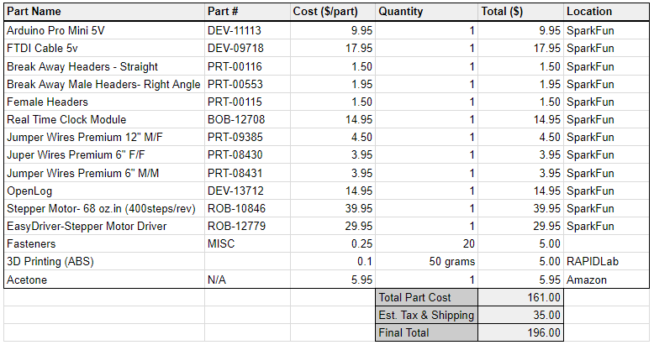

IMPLEMENTATION – Second Semester
This section will describe all manufacturing and assembly of the model as well as problems the team encountered during the implementation of the project and the resulting design changes.

Manufacturing
The utilized method of manufacturing for the antenna gimbal was 3D printing. The team used FORTUS 250mc to print all parts for all iterations of the frame in ABS at the RAPID Lab at NAU. All parts were produced using 100% infill for strength. This design specification is based on weight and strength of the material. Keeping in mind that the team must remain under 0.5 lbs. for their system, their goal is to maximize strength to decrease chances of part failure upon a crash or impact of the UAV. The parts must also be able to support the weight of the antenna and servo motor. After printing an identical part using 20% infill and 100% infill, the team measured the weight and found the change to be insignificant due to the overall volume of the part. Therefore, the team chose to print all parts using 100% infill to maximize the strength. However, since the design is encapsulated between two UAV plates, the team concluded that a direct impact on their design was not probable, and would only need to support the weight of the antenna and motor, therefore did not need to analyze strength any further in their design process. Another requirement considered for the design of the system was simplicity and maintainability. The client requested that no more than four linkages be used in the system, so the team adhered to this requirement in the design phase while still striving to reach and surpass the minimum required angle of 45°. The choice of components to operate the system, the Arduino Mini Pro and Bluebird BMS-35A servo, were driven by the communication, power consumption, and number of modes requirements. These components can communicate at the mandatory 9600 Baud rate and are able to operate on 5V. The use of the Arduino, paired with a servo motor also allows the team to program a user interface that can accept the two required modes, which are to sweep the antenna, or hold it at a specified angle until the user gives a new command. The last requirement considered during the designing and manufacturing process was part installation time. To meet this requirement, the team attempted to create a functioning design with minimal parts required. This decreases the amount of components that need to be removed and replaced in case of part failure, making the system more maintainable.
All components not designed and printed by the team were purchased from vendors. Parts purchased from vendors include all electronics such as the Arduino, wires, cables, and the largest purchase which was the BMS-35A servo motor. This information can be referenced in more detail in Table B1 in the appendices.
The team followed a strict schedule for their manufacturing, detailed in Figure C1 and C2 to stay on track for their project. All deadlines were met, an most were done in advance, especially tasks pertaining to the manufacturing. The team focused on deadlines for the second portion of the project to ensure ample time in case of malfunctions during final product testing.

Design Changes
This section will discuss all iterations of the project after the proposed design in Semester 1 (discussed in chapter 6 of this report) to the final gimbal design. The reasons for change in each iteration are further discussed in each subsection.

First Iteration
The first iteration of the UAV Antenna Gimbal is displayed in Figure 20. This linkage based system was created after receiving several design requests from the client. The main client request was to add a redundant cam arm to aid in stability of the mechanism at the front. Another update from the first proposed design to this first iteration is the change from a small dc motor, to a worm gear driven motor as it would provide more torque. To integrate this system the team needed to add two through holes onto the pivot bases on the left hand side of the device (looking towards the device), as well as adding a semi-circle shaped cut to the cam arm to accept the drive shaft from the motor. A set screw hole was added to enable a tight lock up of parts, on the top of the left side cam arm and a mounting bracket was added to help hold the device together. A sweep cut was needed to be added to the left side cam arm to add clearance for the socket head cap screws which mounted the motor to the mounting bracket. Also depicted in Figure 20 are two boxes representing the Arduino and motor driver used to control the system based on user input.

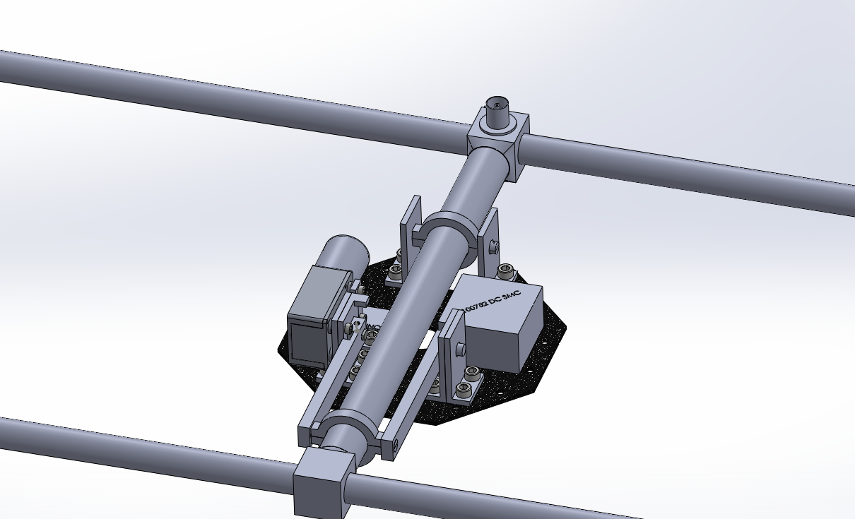
Figure 20: First Iteration Updates

Second Iteration
Several major design changes were made for the second iteration of the gimbal mechanism, displayed in Figure 21. After more research and testing, the team discovered it would be better to use a servo motor rather than a DC motor in their design. Servo motors are easier to program and are capable of going to specified angles, while DC motors are not. DC motors are also often heavier than servos. The chosen motor for this iteration was the Hitec HS-81 Servo. This servo is approximately 1.17 x 0.47 x 1.16 in., 0.04 lbs., and provides 2.34 in.-lbs. of torque. The team chose this motor due to its small size, low weight, and assumption that it would provide enough torque to move the system as desired by the team. The change in motor led to a change in the motor mount as the team created a new part to fasten it to the UAV base plate. The pivot bases were also changed to remove the small holes originally added to mount the first motor. An adapter was created to attach the servo horn to the cam shaft of the assembly so that it could provide movement to the antenna. Since the motor was changed from a DC motor to a servo, the team no longer needs the motor driver that was represented in the first iteration, thus this part was removed.

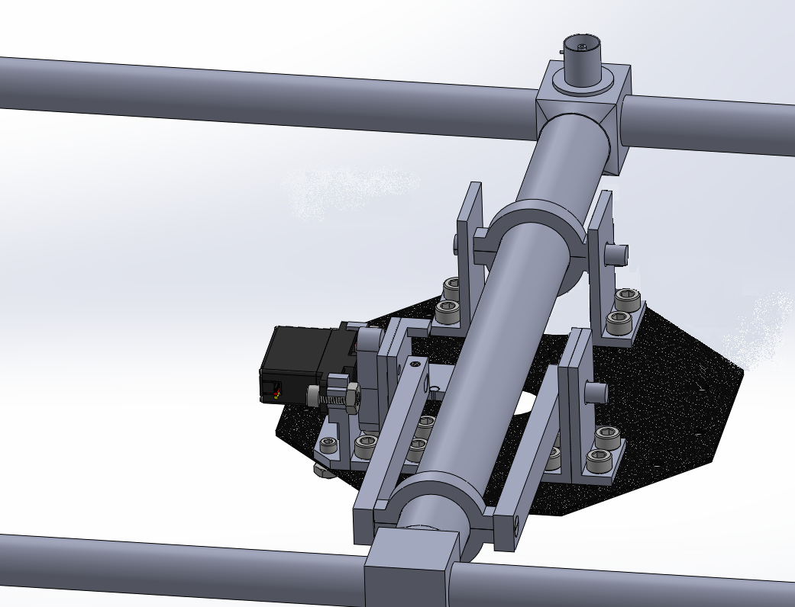
Figure 21: Second Iteration Updates

After designing the second iteration, the team assembled a prototype and attached it to a mock base plate. With the Telonics RA-23K antenna inserted into the design, the team discovered that the pivot base initially meant to only rotate, actually worked better as the sliding and pivoting joint. This led the team to establish the pivot base attached to the cam arms as the static point of contact along the antenna.

The Arduino code written by the team successfully swept the servo horn from 0 to 45 degrees below horizontal as well as to any desired angle in that range. However, when the team conducted an unofficial test of the system it was found that the motor could not lift the antenna seen in figure 22. The team decided to upgrade the motor since they could not confidently say the motor would work 100% of the time.

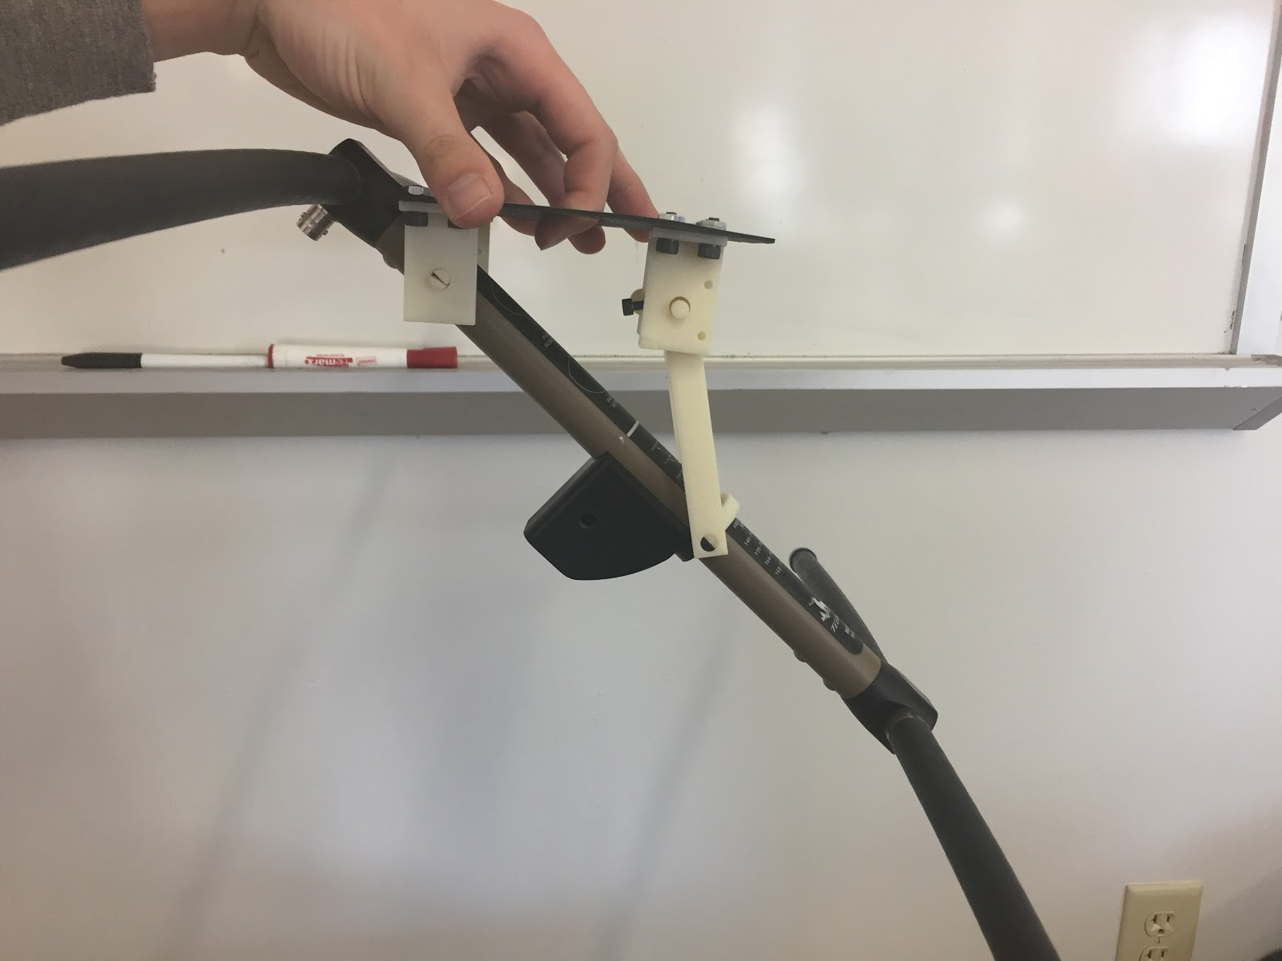
Figure 22: Second Design Iteration Fully Extended

Final Iteration
After building a prototype of the second iteration as discussed in Section 7.2.3, the team implemented several more design changes to reach the final design in Figure 23. The fully assembled design is displayed in Figure 24. The major design change between Iteration 2 and the Final iteration was the change in motor. Due to the results of the test mentioned above, the team changed the motor to the Bluebird BMS-35A servo which could provide more torque resulting in a higher factor of safety. This motor is larger at approximately 1.59 x 0.79 x 1.54 in. in size, and a heavier weight of 0.18 lbs. However, this was still under 40% of the allowable weight of the device, so the team deemed these changes acceptable for a motor that provides 25.2 in.-lbs. of torque. Changing the motor again led to more design changes in the motor mount and the adaptor connecting the motor to the cam arm. The motor mount was increased in size and dimensions accordingly to fit the Bluebird motor. Due to the large sizes of the servo horns provided with the Bluebird motor, the team chose to redesign the method in which the motor is connected to the cam arm. In this iteration, the team mounted the adaptor directly to the output shaft of the motor rather than a servo horn.
Another major design change between the second iteration and the final is seen in the mounting brackets. In the second iteration, the team had one mounting bracket with an edge. This bracket was no longer necessary for calibration and left over from the initial design. Therefore, to unify the parts, the team eliminated this bracket. For all brackets, the team added fillets for better practice and alignment. All drawings of the parts created for the Final Iteration are included in Appendix D.
The final iteration of the system consisted of printing and assembling the new motor mount, adaptor, and brackets, which successfully fit onto the housing plate and aligned with the other existing parts. Holes were drilled into the housing to appropriately locate the mount for future reference when the DASL team CNCs a new carbon fiber plate for the system.
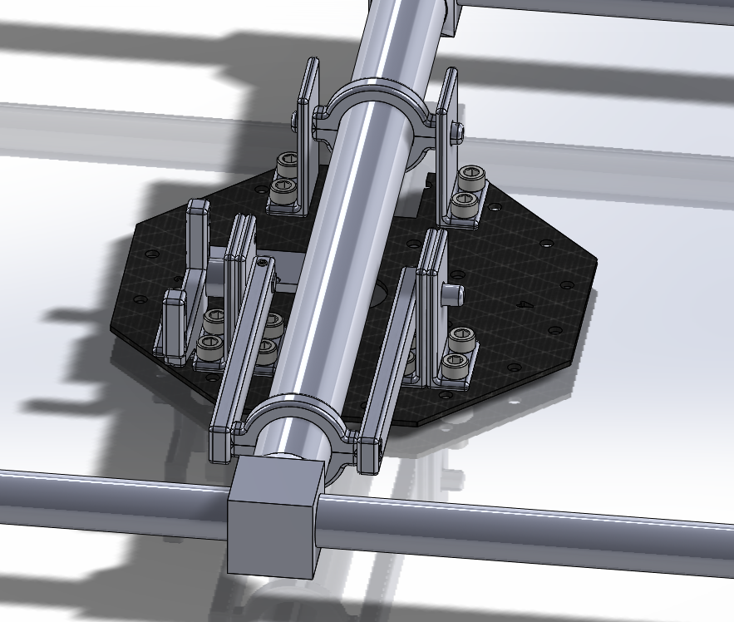
Figure 23: Final Design Model

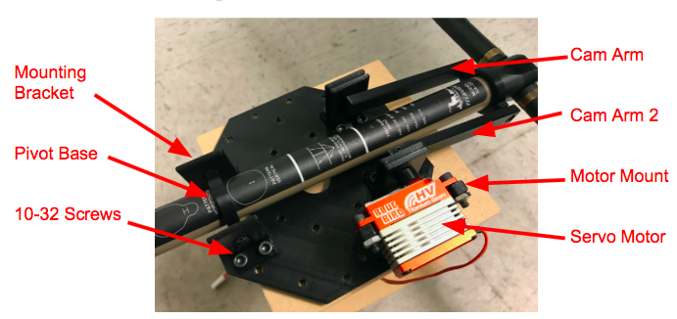
Figure 24: Fully Assembled Final Design

TESTING
This section outlines testing procedures to verify all engineering requirements were met by the system. The majority of the tests are either pass or fail, with no room for tolerances. Each test is described in the following subsections.

Testing Overview
There were ten engineering requirements, as discussed in Chapter 2. Each of these requirements were tested after manufacturing the final product. Their tests and results are further detailed in this section.

Rotational Range
The angle of travel met the ability to go from 0° (horizontal) to 45° below horizontal. It is measured using the angle reported by the system and approximated with a protractor and by eye to ensure a correct reading from the system. The device can travel up to 55° below horizontal as seen in Figure 25, which exceeds the requirement.

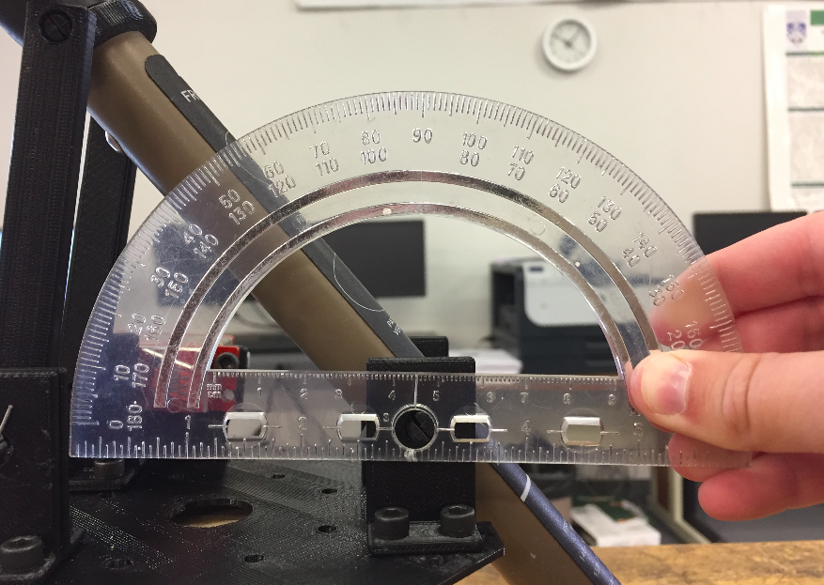

Figure 25: Rotational Range

Modes of Rotation
The device was tested for both stepping and continuous motion. The team ran a program, telling the motor to go to either move to a specific angle, or continuously sweep from 0° to 45°. The motor was then installed into the system and tested with all components to ensure correct function inside the UAV assembly. The system was capable of moving the antenna to a specified angle as well as through the entire angle range continuously, therefore the requirement was met. This test was conducted without measurement tools, as it was observed by watching the movements.

Serial Communication
To allow communication between the Arduino Pro Mini and UAV, the system must operate at the same baud rate. The team was given a specified baud rate of 9600 that should allow the Arduino Pro Mini and Raspberry Pi to communicate. To test the baud rate, the team first set the serial communication in the Arduino code. Then, with the device connected, and serial monitor open, the team was able to confirm a baud rate of 9600 as seen in Figure 26.

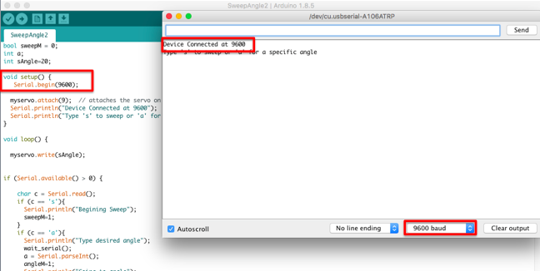
Figure 26: 9600 Baud Rate

Surface Area
The overall surface area of the system mounting to the UAV must be less than 15 in.² in order to fit on the UAV base plate provided by the DASL. This requirement was tested by measuring the surface area of the system that attaches directly to the UAV, such as the top of the mounts. This area was measured with calipers from the Rapid Lab and calculated using the geometry of the shape of the mounts. The surface area of each part is displayed in Table 5. The total area is 4.8405 in.², which is less than 15 in.²; therefore the design passed the size requirement test. Appendix E displays photos of the surface area testing process.

Table 5: Surface Area of Parts
Part | Surface Area (in²) | Quantity of Parts | Total Surface Area (in²)
Mounting Bracket | 0.5047 | 6 | 3.0281
Motor Mount | 0.6044 | 1 | 0.6044
Arduino Mini Pro | 1.2080 | 1 | 1.2080
Total Surface Area of Device (in²) |  |  | 4.8405

Gimbal Weight
To test the weight requirement, the system was weighed with two scales provided by the Rapid Lab. All components of the device were placed on the small scale individually to measure the weight of the parts. To ensure these measurements were accurate, the team also placed all the parts on a larger scale at once to compare to the additive weight of each part. The additive weight totaled at 0.4086 lbs, and the collective weight was 0.40 lbs. The difference in these weights could be explained by the difference in tolerances of the scales used. The total weight of the device fitted within the allotted requirement of 0.5 lbs. Each weight is listed in Table 6, and photos can be referenced in Figure F1-F11.

Table 6: Weight of Parts
Part | Weight (lbs) | Quantity of Parts | Total Part Weight (lbs)
Mounting Bracket | 0.0077 | 6 | 0.0462
Motor Mount | 0.0104 | 1 | 0.0104
Cam Arm 1 | 0.0140 | 1 | 0.0140
Cam Arm 2 | 0.0137 | 1 | 0.0137
Pivot Base | 0.0032 | 4 | 0.0128
10-32 Screws | 0.0051 | 14 | 0.0714
10-32 Nuts | 0.0024 | 16 | 0.0384
M-5 Screws | 0.0047 | 2 | 0.0094
Arduino Pro Mini (and wires) | 0.0134 | 1 | 0.0134
Servo Motor | 0.1789 | 1 | 0.1789
Total Weight of Device |  |  | 0.4086

Voltage
The power input test was conducted using a digital multimeter (DMM) provided by the Rapid Lab to measure the voltage required to operate the device. The team’s device must be run on 5 V. This is the amount of volts the DASL UAV can supply to the device during flight. The DMM was used to measure the voltage being consumed by the system in a paused operational state. The total voltage being consumed by the system is 5.11 V. Although this is higher than the allotted 5V, the client confirmed that it was within acceptable tolerances and therefore meets the requirement as seen in the DMM in Figure 27.
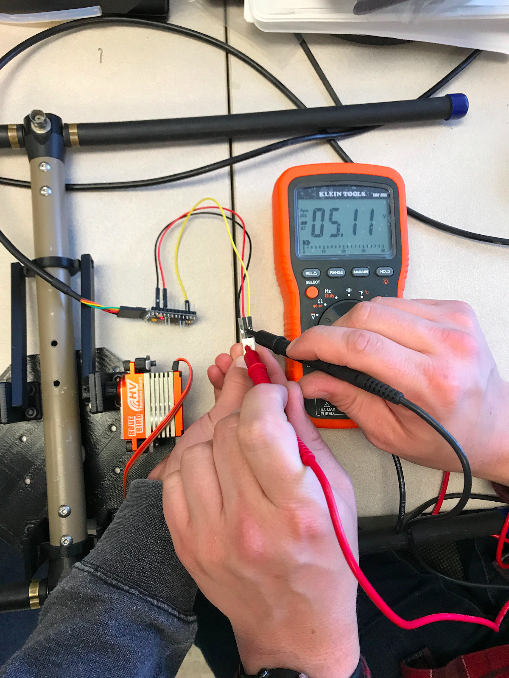
Figure 27: Voltage Reading

Cost
All costs for components and services did not exceed the budget of $500. This requirement was tested by adding the total cost of components for the gimbal system. The total budget, as seen in Table B1 in the appendicies is $193.89, which is less than $500; therefore the requirement is met.

Part Installation Time
Part installation time must be under 1 hour. If one part is broken, it must be able to be fixed in under 1 hour. To ensure any part can be fixed in the allotted time, the team conducted multiple trials of replacing the entire system. This was done using an iPhone timer with a resolution of 0.01s. The team conducted 3 trials for this test, timing the disassembly and assembly of the system. The results of these trials are displayed in Table 8. The largest time trial for this test was 22:36 minutes, and the average time was 17:14 minutes. Since entire system can be replaced in well under one hour, any part of the system can be replaced in the allotted hour per the team’s requirement.

Table 8: Time Trials
Trial | Disassembly Time (min:sec) | Assembly Time (min:sec) |  | Total Time (min:sec)
1 | 4:09 |  | 18:27 | 22:36
2 | 7:30 |  | 7:47 | 15:17
3 | 2:17 |  | 11:33 | 13:50
Average | 4:39 |  | 12:31 | 17:14

Number of Tools
The number of tools test was conducted simultaneously with the part installation time test. The team was able to entirely assemble and disassemble the product using only three tools, which included a wrench, an allen wrench, and needle nose pliers. Therefore, the requirement was met.

Linkages
The total number of moving components did not exceed 4. This requirement was tested by counting the number of linkages present in the design. There were no special tools or equipment required to measure this specification. There are 3 links in this mechanism as circled in Figure 28.
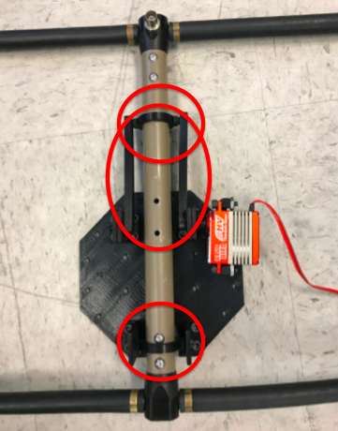
Figure 28: Linkages

Summary of Testing
In summary, all engineering requirements were met if not exceeded. The only discrepancy found in testing was through the voltage test. The device pulled 5.11V and the limit was 5V. However, after further discussion with the client, the voltage was deemed acceptable as it was within a 0.15V tolerance. All requirements, targets, and final product results are displayed in Table 9.
Table 9: Testing Results
Requirement | Target | Final Product
Rotational Range | $≥$45$°$ | 60$°$
Modes | $≥$2 modes | 2 modes
Communication | 9600 bit/s | 9600 bit/s
Surface Area | $≤$15 in.² | 4.84 in.²
Weight | $≤$0.5 lbs | 0.41 lbs
Voltage | $≤$5 V | 5.11 V
Cost | $≤$$500 | $193.89
Installation Time | $≤$60 min. | 17.25 min
Number of Tools | $≤$3 tools | 3 tools
Linkages | $≤$4 links | 3 links

Conclusions
This section discusses the team’s progress throughout the project. It describes the contributions to success including ground rules, coping strategies, and design methods. Lastly, the team details room for improvement in the future.

Contributors to Success
The team successfully completed the purpose and goals stated in the team charter. The team’s purpose was to build a gimbal attachment for a RA-23K antenna, allowing connection to a UAV. This attachment allows for better tracking of wildlife tagged with VHF telemetry tags as pitching the antenna helps to direct the radiation reception pattern in a more efficient way. This project was successfully completed as explained in the testing section of the report. Through product testing, all engineering requirements provided for this project were met, to work towards customer satisfaction. The team also met the goals for this project which were to provide a quality product that exceeds the customer’s expectations. The team also worked towards a product that could be used in more real life applications across the world such as tracking of animals in national parks or on wildlife preserves. While the team’s final product has not been placed on other UAVs, it has the potential to be transferred from vehicle to vehicle allowing it to meet their goal of being used on a wider scale. This success can be attributed to the teams constant efforts to meet the overall purpose and goals of the project. The team also continuously worked towards their personal goal of ensuring the project is fully functional, durable, and aesthetically pleasing. All of this has been put into their work in the design, CAD model, prototype, final product, and report, satisfying the goal.
The majority of the ground rules stated in the team charter were followed, contributing to the team’s success. Ground rules set by the team include meeting on time, no personal distractions (such as cell phones), respect for all members, and responsibility for any individual work needed for the team. All members showed respect for eachother and kept positive attitudes even when more strain was put on the team at certain times during the project. When extra work needed to be done there was a sense of individual responsibility and at least one member, if not all, were always willing to put in the extra time. The team also respected one another’s personal time and would try to distribute work as to not over burden any specific member. Throughout the semester each member felt a sense of unity and desire to succeed on this project and it was reflected in their actions and work.
Coping strategies were also implemented to help the team on their path to success. As explained in the team charter, the team followed their guidelines for solving problems such as ties in a team vote since there is an even number of members. All ties went to further discussion of each idea and re-voted on. In this way the team was able to handle all decisions without conflict. Other issues such as tardiness and loss of focus during team meetings were brought up promptly to avoid any future problems and help the team stay on track. These strategies worked well for the team as all members were respectful of each others’ time and knew the importance of tasks at hand.
In addition to a positive team performance, the team excelled in several areas of project performance including time management, manufacturing, and budgeting. From the first semester to the second, the team greatly improved on their time management pertaining especially to project deadlines. The team completed most project requirements approximately one week before the deadline. This left ample time for any minor adjustments that needed to be made. The manufacturing of the project also went smoothly contributing to project success. After manufacturing a prototype, the team noted sever minor changes that needed to be made such as tolerancing and addition of fillets. Through these small adjustments, the final product was assembled nearly flawlessly. Since all non purchased parts were 3D printed rather than machined, they were able to be completed in approximately 3 hours with more precise unity, which improved the structural integrity and aesthetic appeal of the final product. Lastly, the team excelled in budgeting their project. The final budget was under $200, meaning the team only used about 40% of their allowed $500. This helped to keep the project maintainable as most components that are susceptible to breaking are 3D printed, and the user can reprint the entire system for a very low cost (under $15).
The tool that contributed the most to the team’s success was the House of Quality. By comparing each of the customer needs to the technical requirements the team was able to assign a relative technical importance to each engineering requirement. This lead the team to focus the strongest on the highest ranking requirements, which are part installation time, rotational range, number of linkages, and mass. Each of these areas are crucial to the overall functionality of the system, so the team knew to incorporate them heavily when designing the current system. The team also benefited greatly from design iteration. Through all of their iterations, including CAD models and the prototype, the team was able to improve the stability, torque, operations, and functionality of the design.

Opportunities/areas for improvement
Although the team was more successful than not, there were still issues that arose during the year. A small improvement could be made in the professionalism of meetings. As previously stated the team was well acquainted before the project which led to poor use of meeting time in the first semester. The team drastically improved staying on task during meetings, there is still room for improvement for the professionalism of meetings. Although the team members are friends, the team should treat the meeting time as practice for real world professional meetings. In this sense, all personal topics should be reserved until the meeting is concluded. This would help the team to be more efficient during meetings. Although overall time management for deadlines was always ahead of schedule, there were several unnecessary meetings due to the lack of productivity in others.
The biggest obstacle the team faced was poor communication. While the team was occasionally in contact with several other individuals working for the DASL lab, communication between the team and the client was lacking. During the first semester the team generated a few designs with a decision matrix, including one that consisted of the antenna being pinned in the center and attached to the bottom of the UAV by two long mounts. The team had 3D printed a rough prototype before meeting with the client, whom then suggested the team pursue their third ranked concept from the decision matrix. This could have been avoided by meeting with the client before making the initial prototype. Although the client did not have ample time to meet often with the team, this could have been successful by either a simple email or five minute trip to the client’s office hours. Improved communication would have saved the team much time the team wasted on irrelevant designs. For example, if the team would have communicated their initial design, they could have designated more time towards improving the current linkage design desired by the client. There were several other communication errors throughout the year such as needing the antenna for building and testing purposes, and not knowing the client had a spare antenna for the team to use. Also the time to get a carbon fiber base plate from the lab took longer than anticipated, however this obstacle was overcome by using a 3D printed plate until the appropriate one arrived. Future communication between the client and the team should happen on a regular basis to ensure all ideas are properly discussed whether it be through in person meetings or email.
As the Team Charter aided to the project success, it also left room for the team to improve. It is apparent that it would be beneficial to the team to occasionally review the charter to constantly keep the team purpose and goals in mind. Doing this would help the team stay focused on the success of this project and the importance it has to our clients as well as the natural wildlife research community. The Team Charter did not predict non professionalism or poor communication as a potential barrier. Since these are issues that were apparent in both semesters, the team could have greatly benefitted by revising the Potential Barriers and Coping Strategies section of the Team Charter to include these obstacles. This would give the team a reference when struggling with communication or a reminder to practice professionalism for the real world.
The major aspect of project performance that could use improvement was the product quality. There were small additions made to the device after fully assembled that the team deemed necessary. One of these were the addition of cotter pins to prevent the pivot bases from slipping out of the mounting brackets. This addition was thought of during brainstorming sessions but left out of the design until the very end. Due to this, the team used paper clips rather than real cotter pins. The holes left for these pins were slightly too small and resulted in forceful procedures to make the paperclips fit. This affects the product quality as it looks unstable (although functions quite well) and takes away from the over all aesthetics of the device.
The major engineering methodology to cause set backs to the team and needs improvement is the decision matrix. This process is not fully determinate and the team could sway the numbers to the one they prefer and it was not immune to personal bias. This process could have improved by also having the client rank the top four that the team chose. This would help to direct the team more in the direction of the client’s idea for the project, rather than what they think may be best.
Overall, the major steps for improvement include conducting more professional meetings, structuring better communication with the client, revising the team charter after the first portion of the project, paying more attention to product quality, and creating a non biased system for the decision matrix.

REFERENCES

[1] S. Oman “Mechanical Engineering Capstone Projects.” (2017, August). [Print].

[2] “Tracking Wildlife | Wildlife Journal Junior,” Wildlife Journal Junior. [Online]. Available:
http://www.nhptv.org/wild/tracking.asp. [Accessed: 25-Sep-2017].

[3] T. Inc., “RA-23K VHF Antenna,” RA-23K VHF Antenna | Telonics Inc. [Online]. Available:
http://www.telonics.com/products/vhfAntennas/RA-23K.php. [Accessed: 25-Sep-2017].

[4] M. Leonardo et al. (2013). A Miniature Wildlife Tracking UAV Payload System using Acoustic Biotelemetry. Proceedings of the ASME Design Engineering Technical Conference. [Print]. Volume 4

[5] T. Consi et al. (2016, February). An Unmanned Aerial Vehicle for Localization of radio-tagged sturgeon. OCEANS. [Print].

[6] Inc., Moog. “Antenna Pointing Mechanisms.” MOOG, 2017. [Online]. Available: http://www.moog.com/content/sites/global/en/products/actuators-servoactuators/space/spacecraft/antenna-pointing-mechanisms.html. [Accessed: 06-Oct-2017].

[7] “UAV TRACKING ANTENNA.” Octopus ISR Systems. [Online]. Available:
http://octopus.uavfactory.com/uav-payloads-equipment/portable-tracking-antenna. [Accessed: 06-Oct-2017].

[8] “Retractable Gimbal Payload.” Marcus UAV Unmanned Aerial Vehicles, 2016. [Online]. Available:
http://www.marcusuav.com/gimbal/. [Accessed: 06-Oct-2017].

[9] C. Davis, “Arduino Alternatives: 5 Microcontrollers You Should Know,” Popular Mechanics,
11-Nov-2015. [Online]. Available:
http://www.popularmechanics.com/technology/how-to/g1426/arduino-alternatives-5-microcontrollers-you-should-know/. [Accessed: 06-Oct-2017].

[10] “Servo Motors (Motor Only),” Servo Motors (Moor Only). [Online]. Available:
http://www.orientalmotor.com/servo-motors/servo-motor-only.html. [Accessed: 28 Sept. 2017].

[11] Robotshop.com. (2017). 2.5kg Goteck Metal Gear Micro Servo. [Online] Available:
http://www.robotshop.com/en/25kg-goteck-metal-gear-micro-servo.html [Accessed 28 Oct. 2017].

[12] “Pololu - Power HD High-Speed Digital Micro Servo DSM44,” Pololu Robotics &
Electronics. [Online]. Available: https://www.pololu.com/product/2142. [Accessed:
28 Sept. 2017].

[13] “Channel Master 3079 Antenna Mount Kit - 2 Pack: Home Audio & Theater,” Amazon.com:
Channel Master 3079 Antenna Mount Kit - 2 Pack: Home Audio & Theater. [Online].
Available:https://www.amazon.com/Channel-Master-3079-Antenna-Mount/dp/B002SAO
HH2. [Accessed: 28 Sept. 2017].

[14] “McMaster-Carr,” McMaster-Carr. [Online]. Available:
https://www.mcmaster.com/#1755a11/=19jlcud. [Accessed: 28 Sep 2017].

[15] MIKEP313, Eddie, Richelieu, Danny, Brynn, Richierich03, Bonair, and MomtheBuilder,
“Everbilt 1-1/2 in. Zinc-Plated Corner Brace (4-Pack)-15304,” The Home Depot,
13-Jun-2017. [Online]. Available:
http://www.homedepot.com/p/Everbilt-1-1-2-in-Zinc-Plated-Corner-Brace-4-Pack-15304/202033892. [Accessed: 28-Sep-2017].
[16] “SparkFun,” SparkFun. [Online]. Available: https://www.sparkfun.com/ [Accessed: 28 Sep 2017].

APPENDICES

Appendix A: Semester 1 Proposed Design Drawings

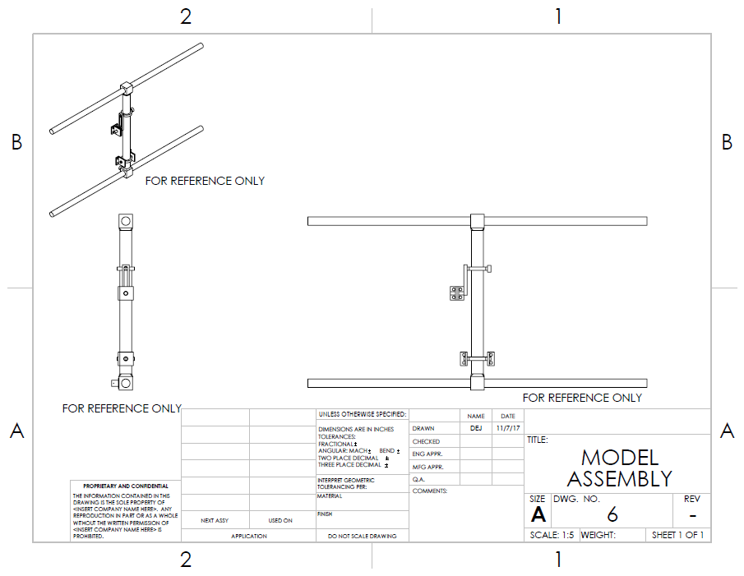
Figure A1: Assembly Drawing

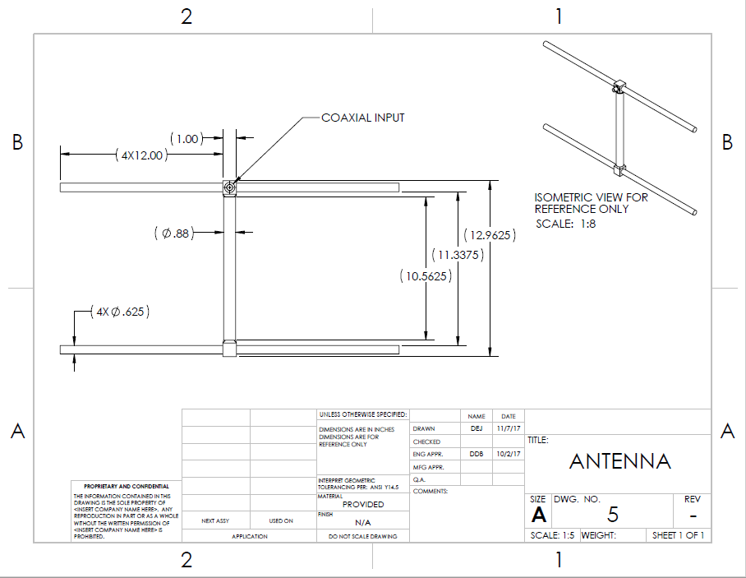
Figure A2: Antenna Drawing

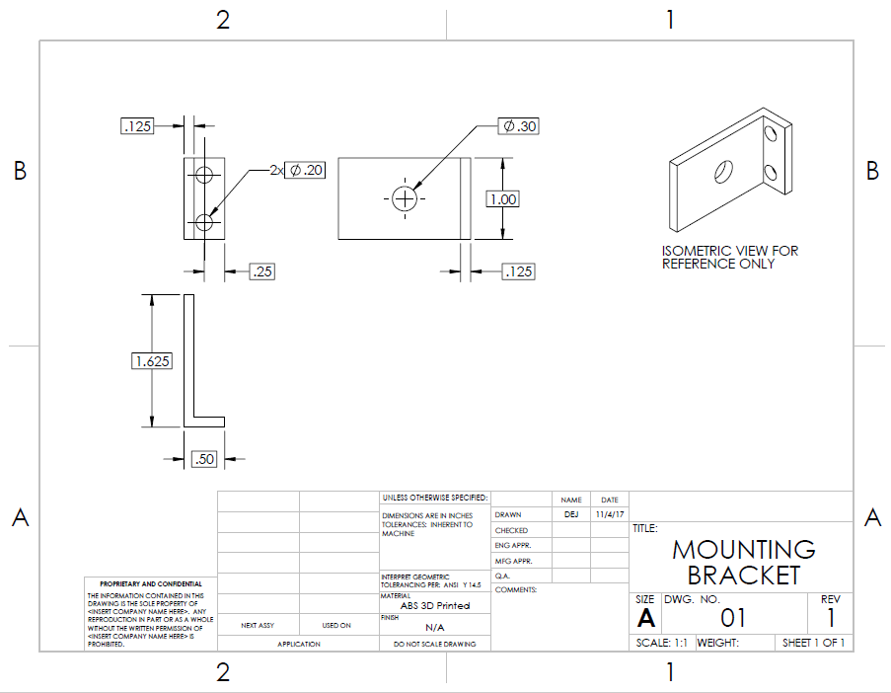
Figure A3: Mounting Bracket Drawing

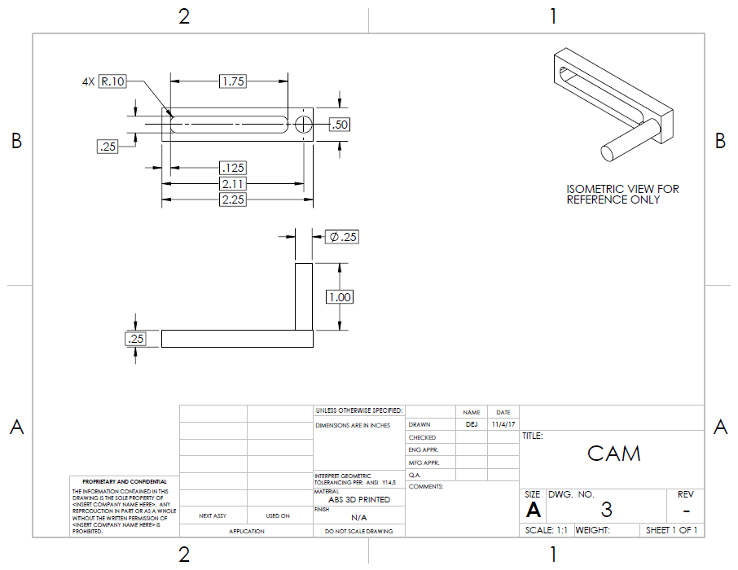
Figure A4: Cam Drawing
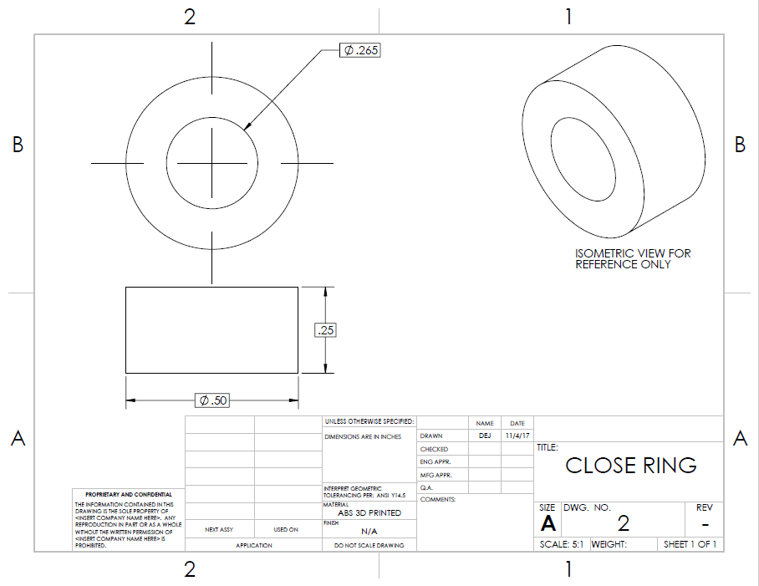
Figure A5: Close Ring Drawing

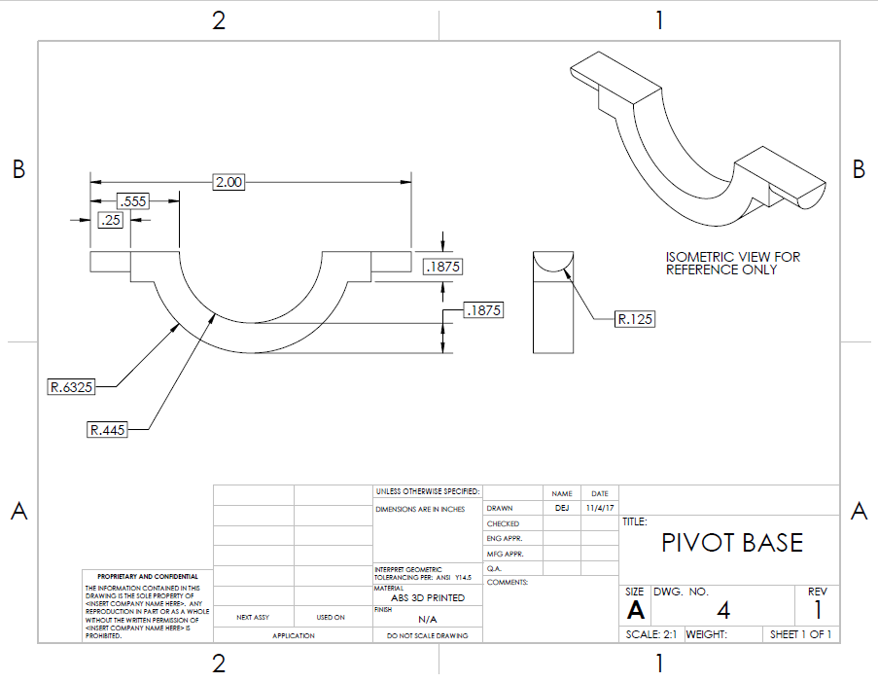
Figure A6: Pivot Base Drawing

Appendix B: Second Semester Schedule

Table B1: Final Design Budget
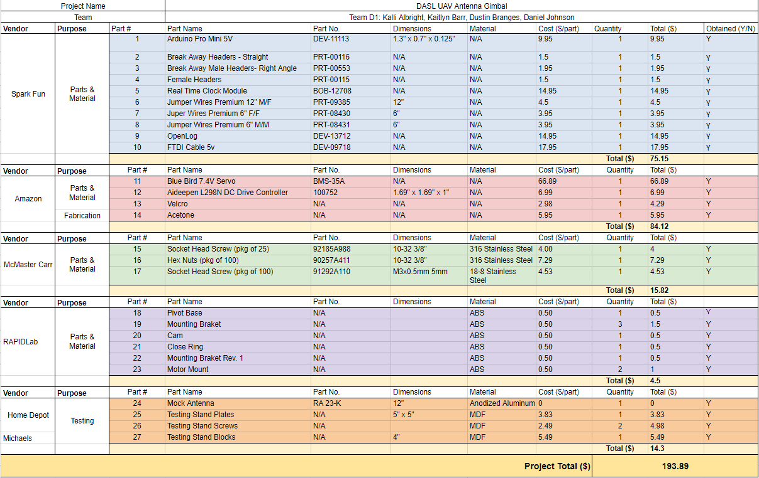

Appendix C: Final Design Budget

Table C1: Second Semester Weeks 1-9
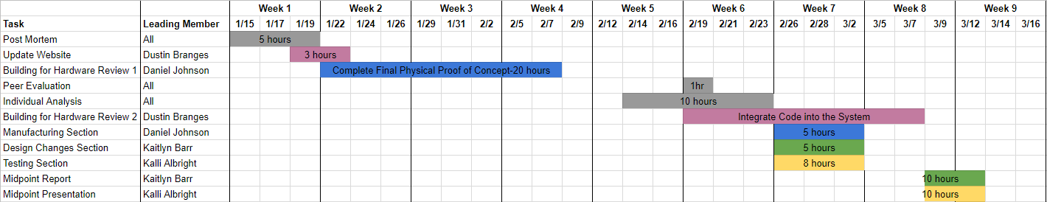

Table C2: Second Semester Weeks 10-15
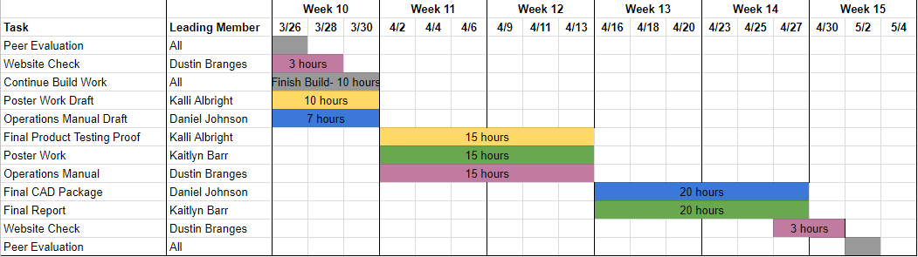

Appendix D: Final Design Part Drawings

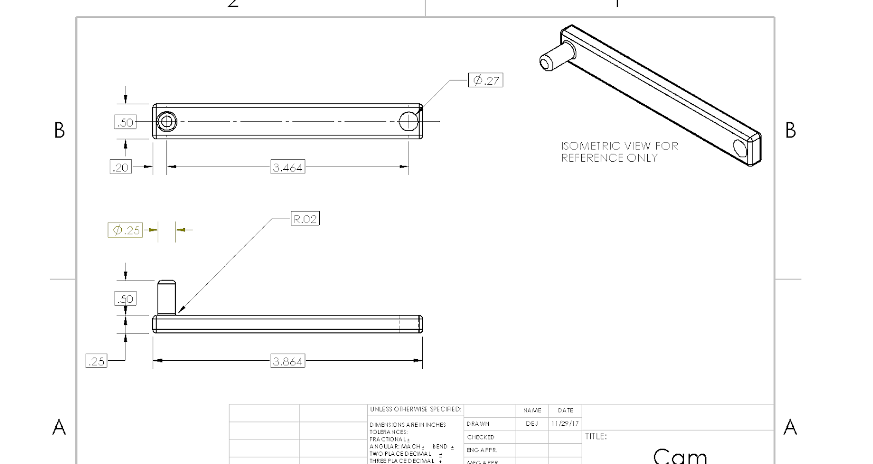
Figure D1: Cam Arm Drawing
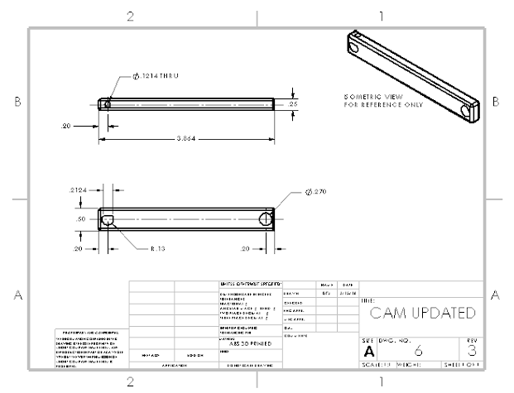
Figure D2: Cam Arm 2 Drawing

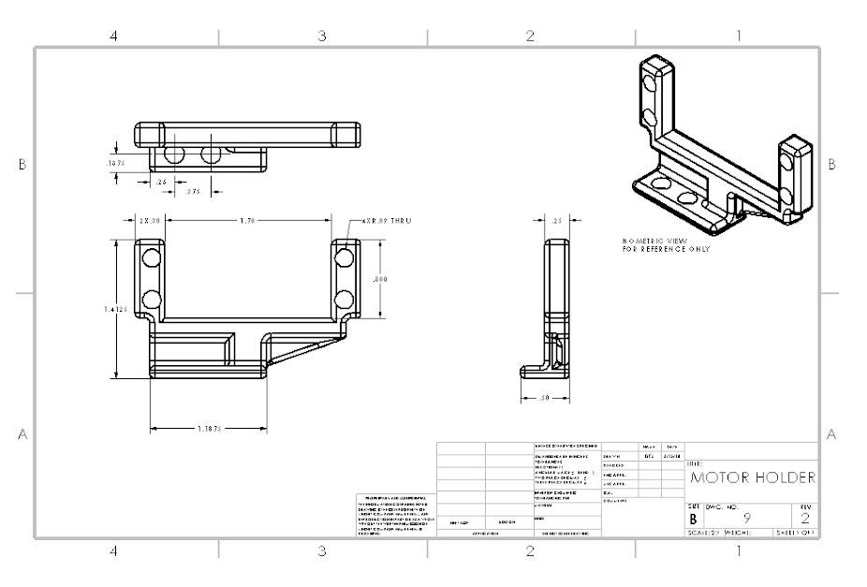
Figure D3: Motor Mount Drawing

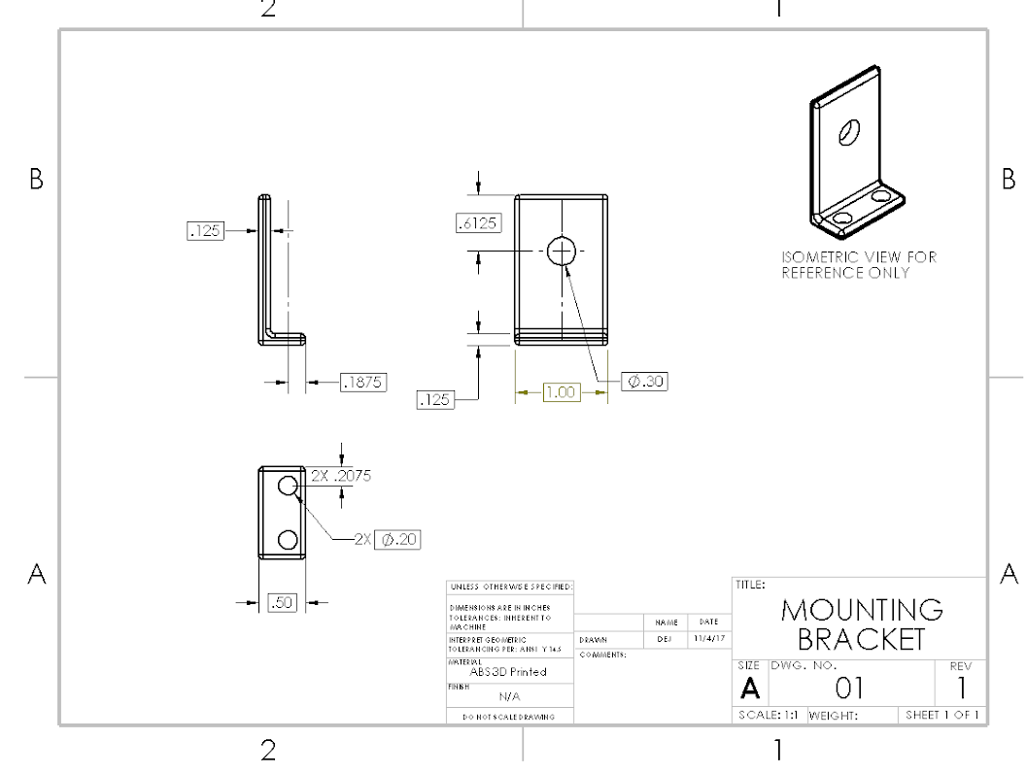
Figure D4: Mounting Bracket Drawing

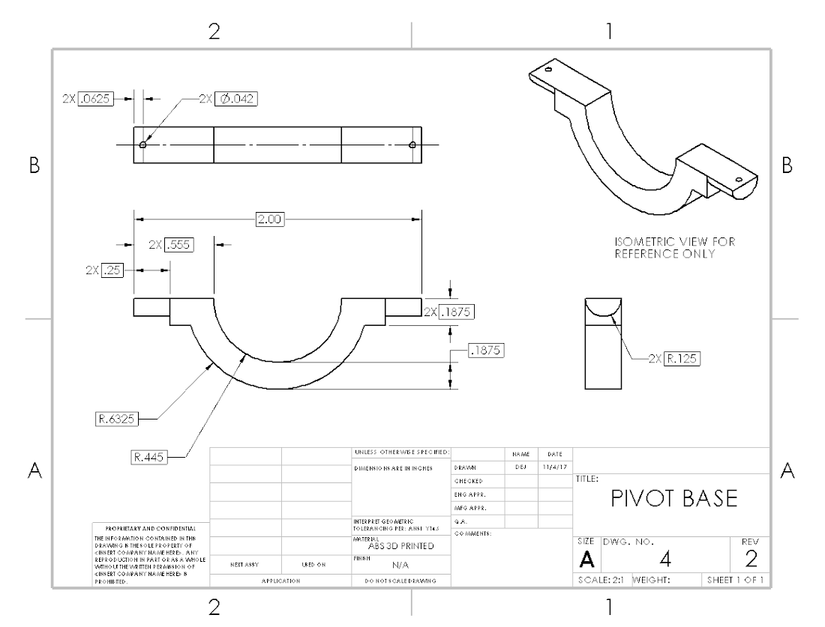
Figure D5: Pivot Base Drawing

Appendix E: Size Testing
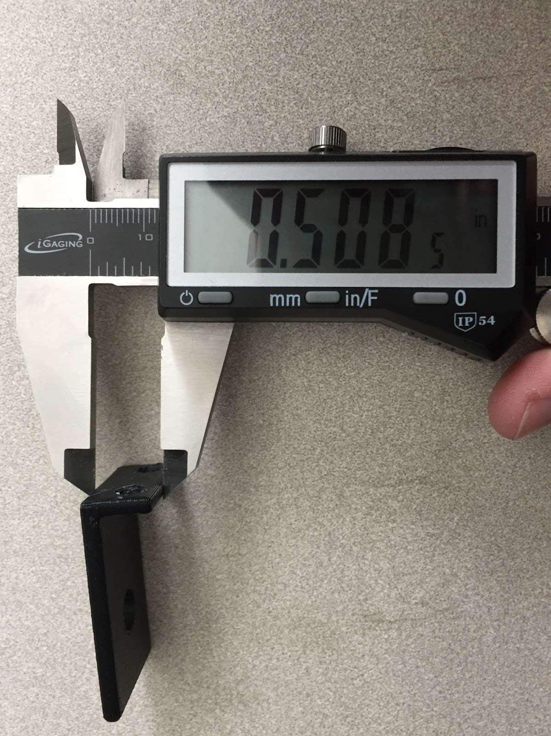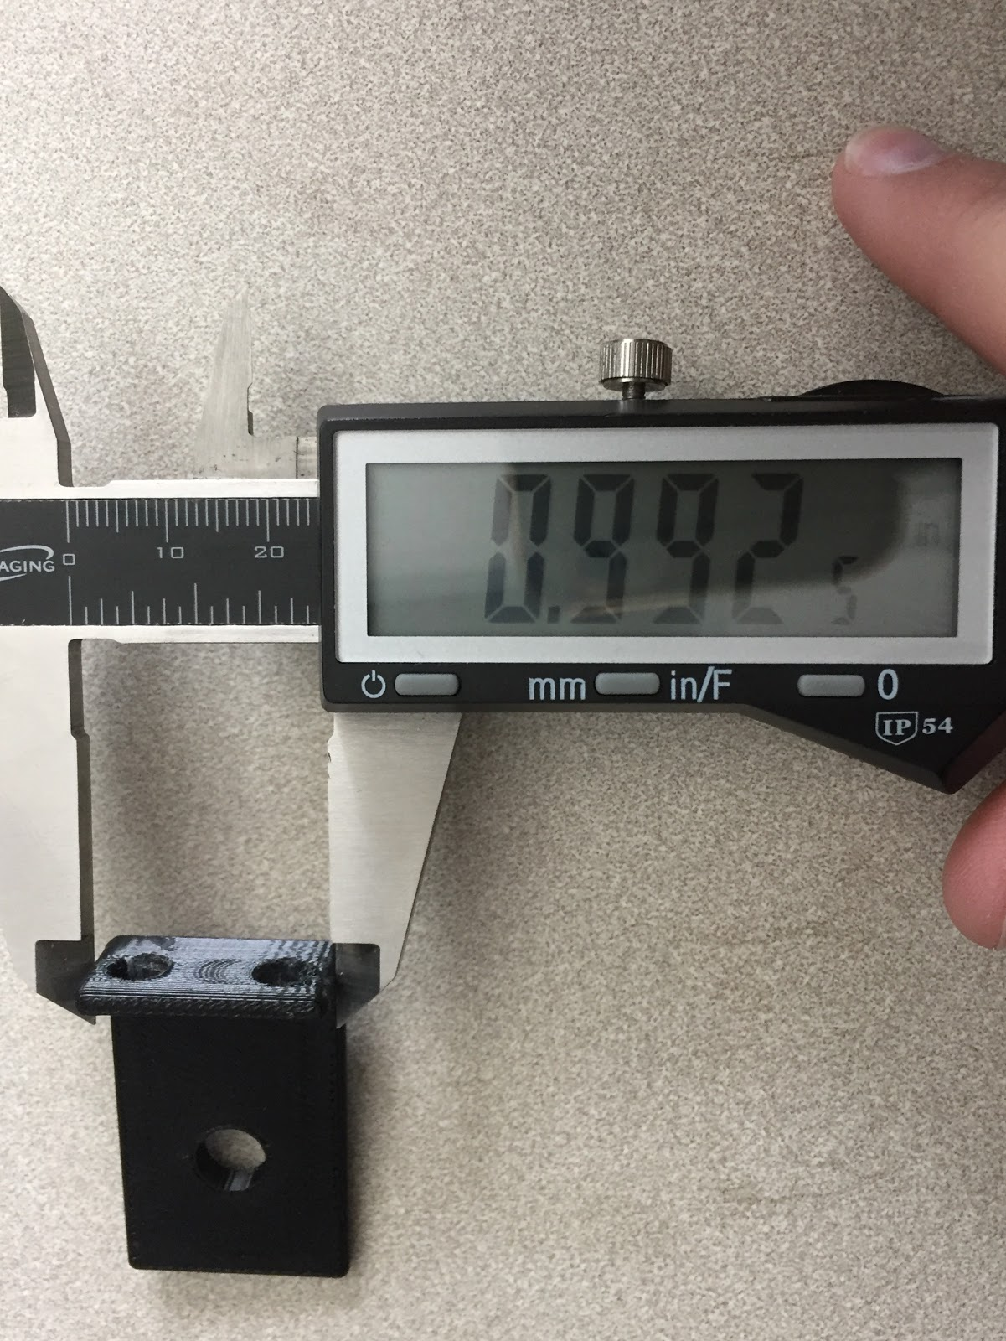
Figure E1: Width of Mounting Bracket Figure E2: Length of Mounting Bracket

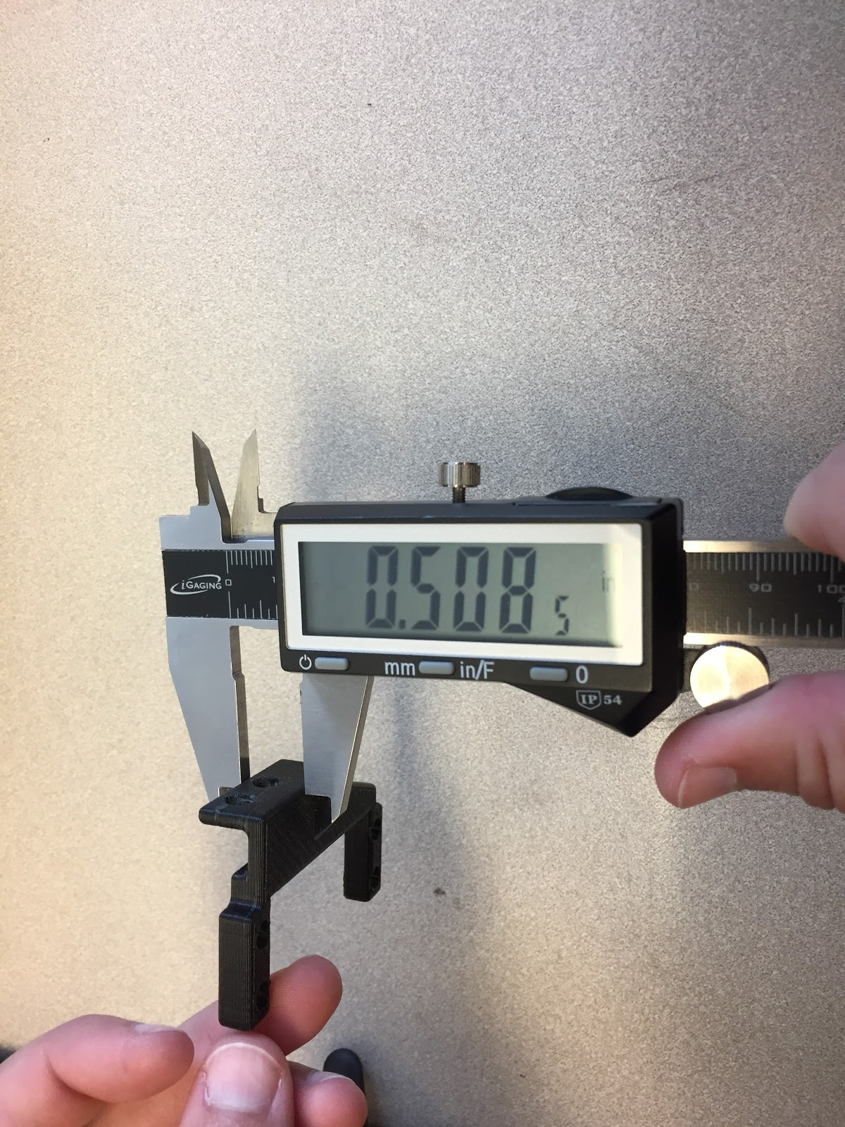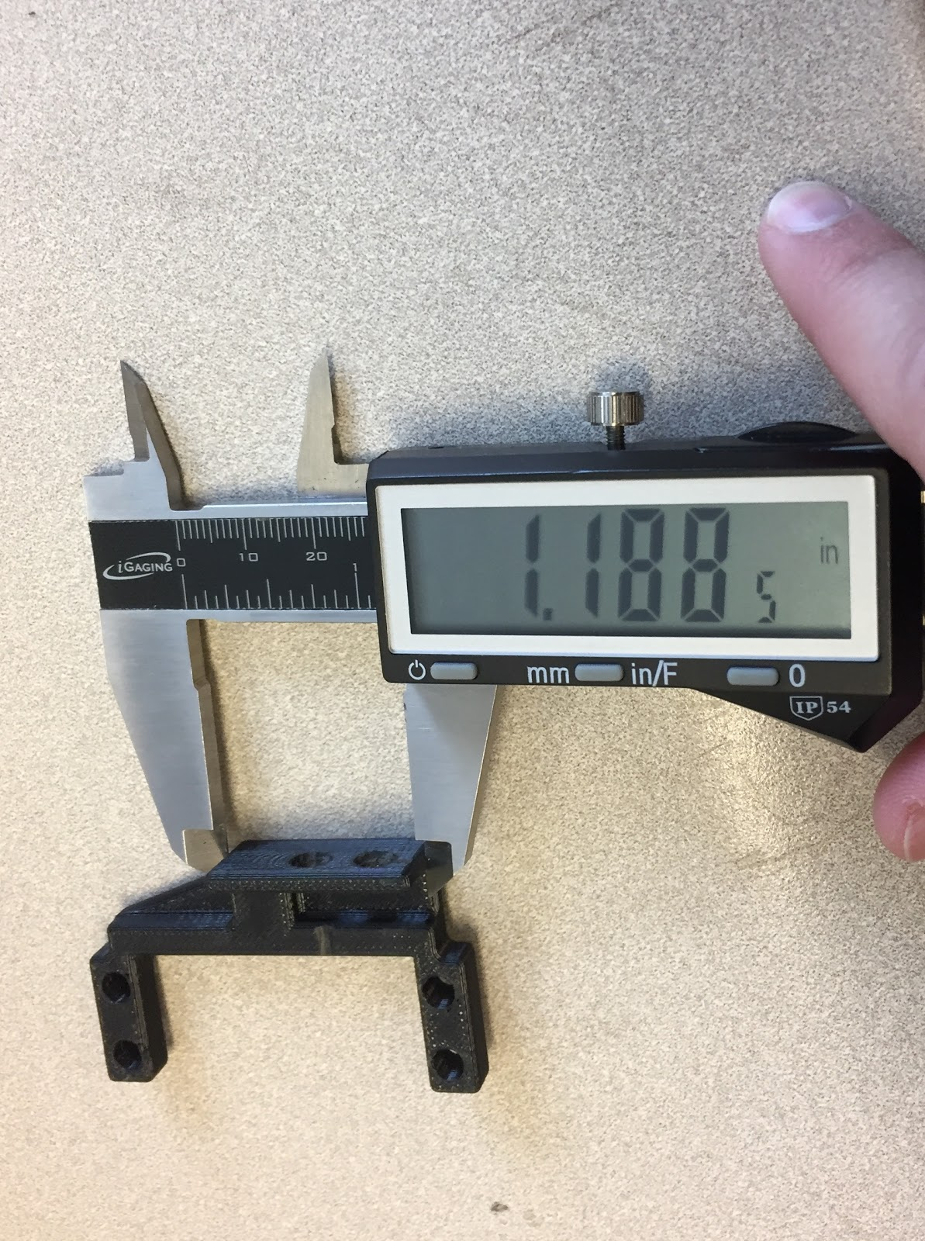
Figure E3: Width of Motor Mount Figure E4: Length of Motor Mount

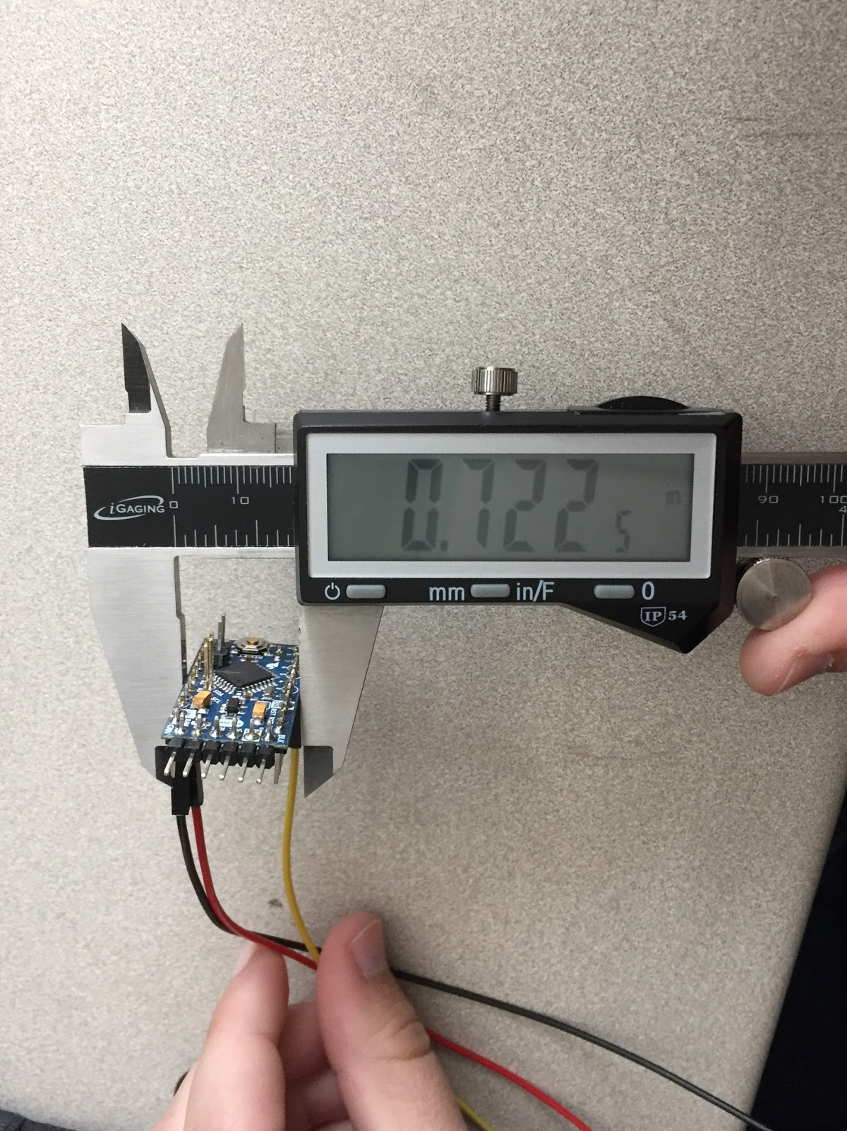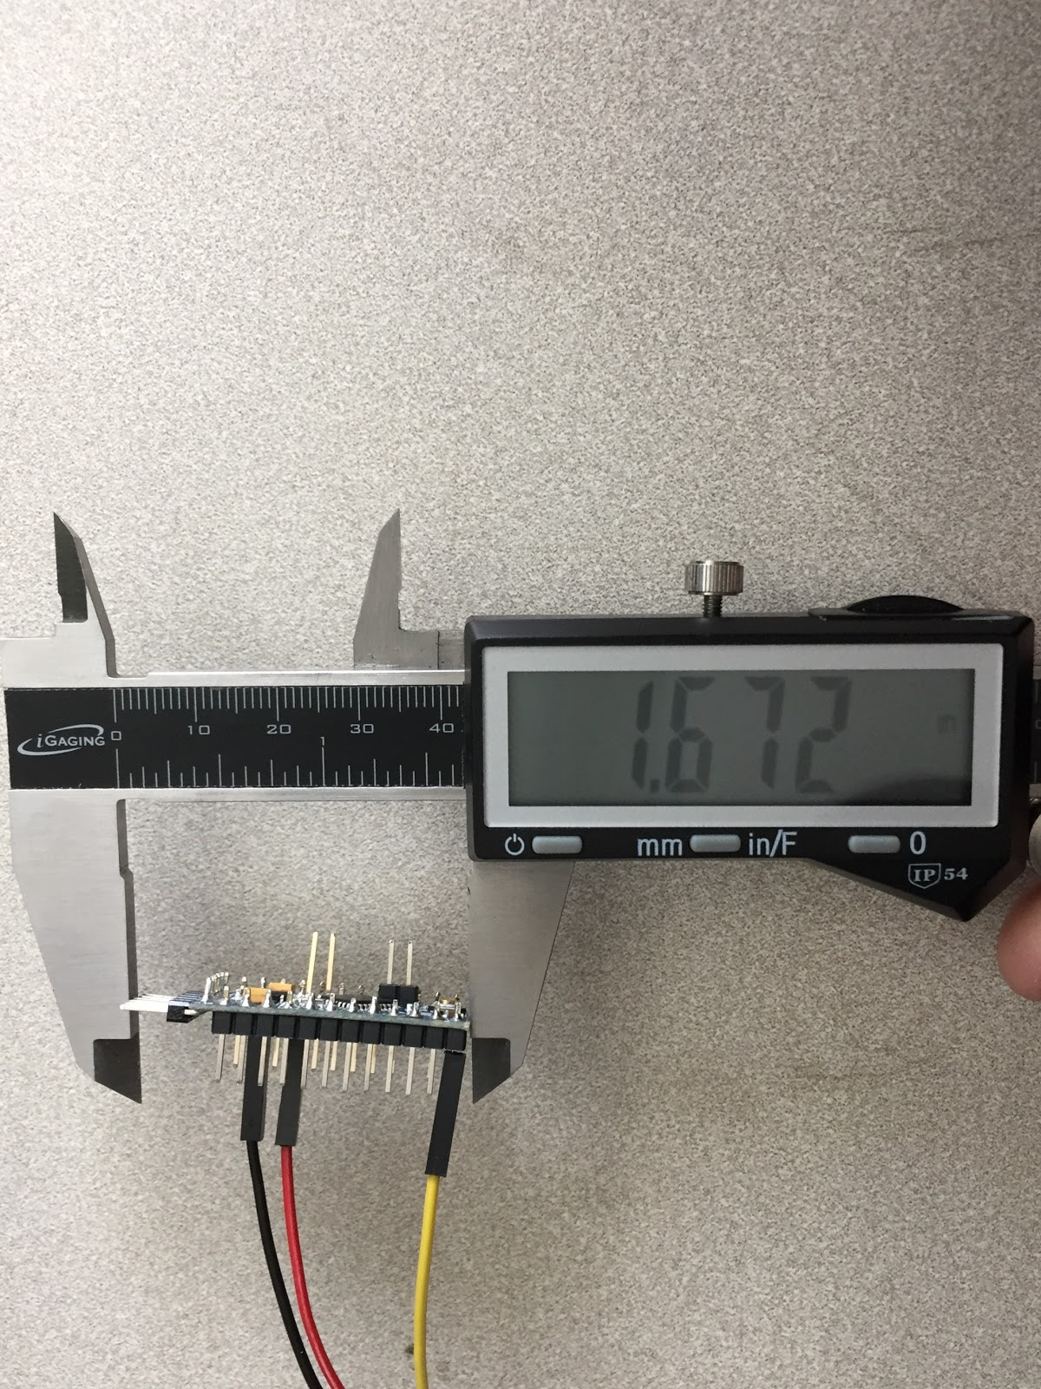
Figure E5: Width of Arduino Figure E6: Length of Arduino

Appendix F: Weight Testing

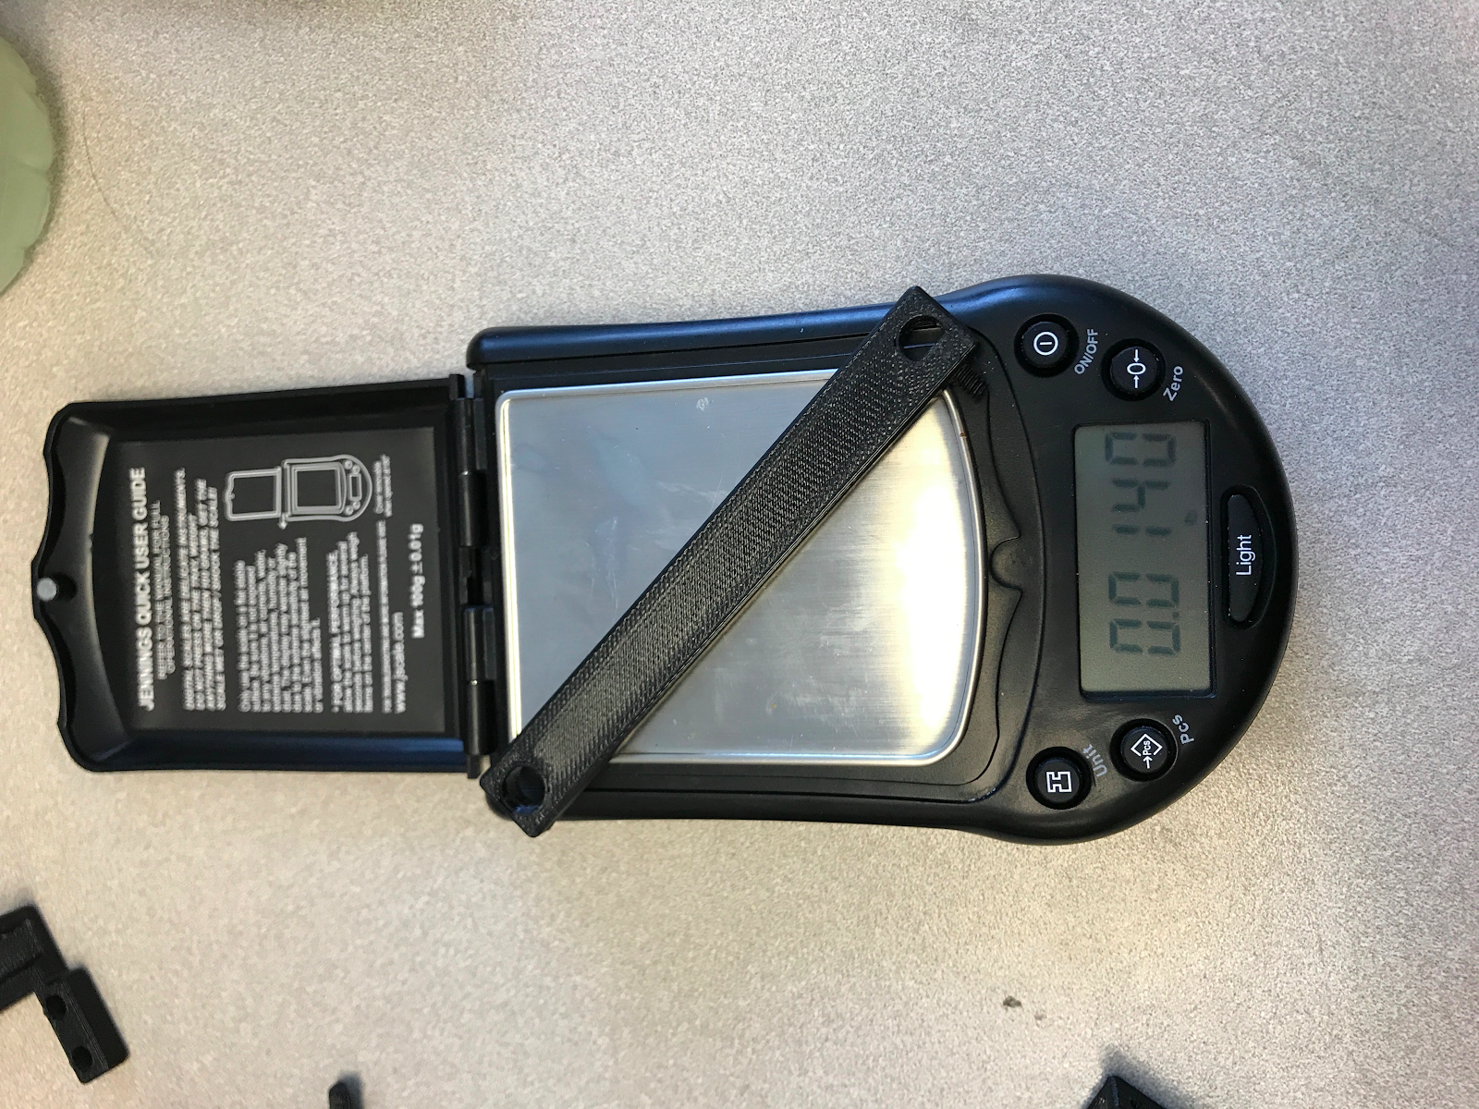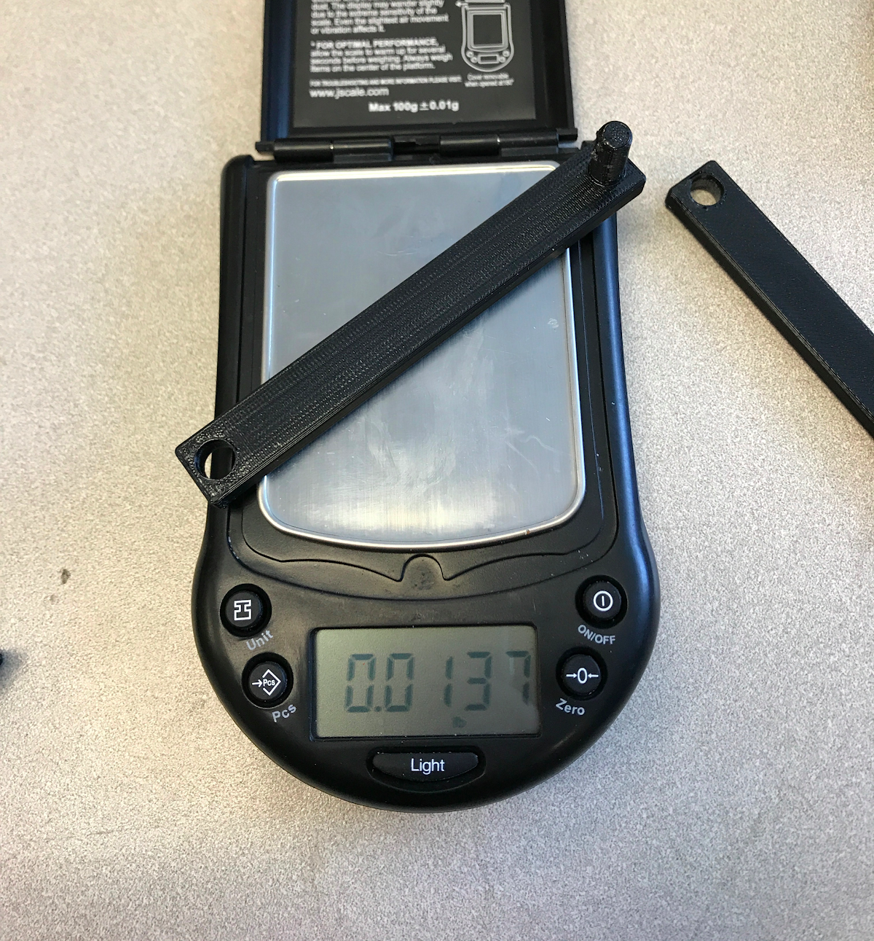
Figure F1: Cam Arm 1 Weight Figure F2: Cam Arm 2 Weight

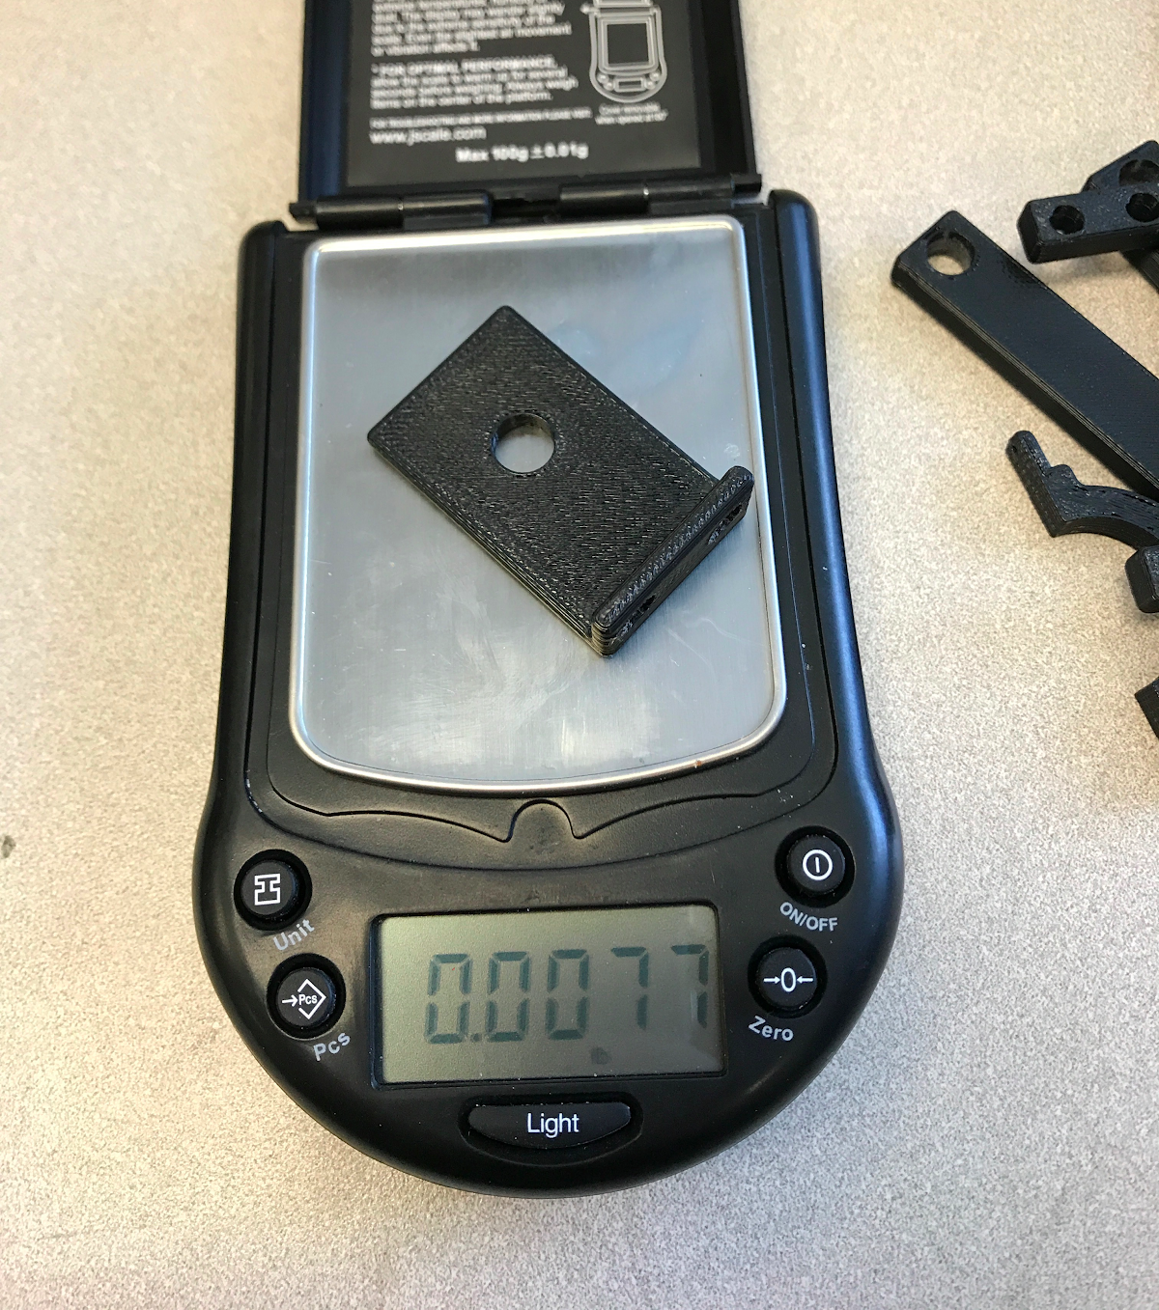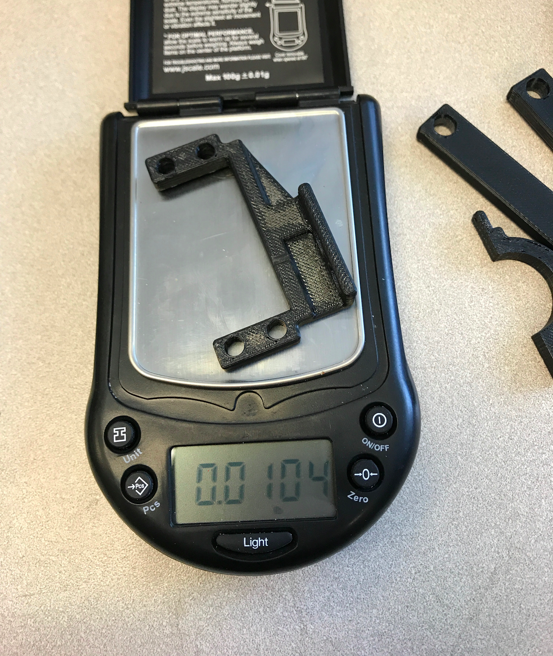
Figure F3: Mounting Bracket Weight Figure F4: Motor Mount Weight
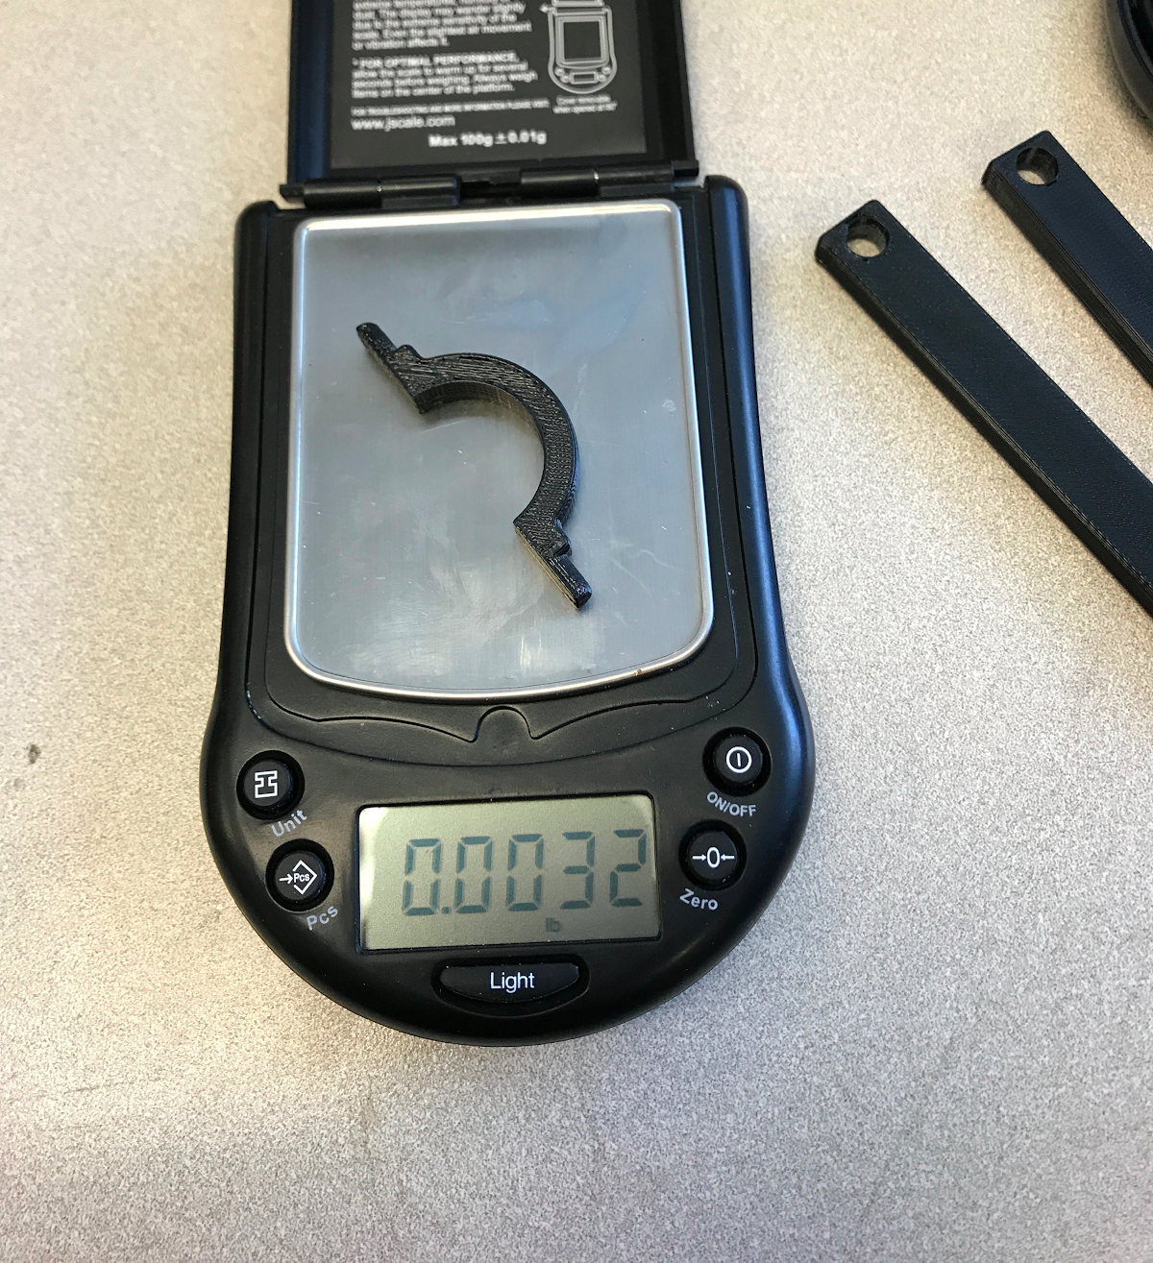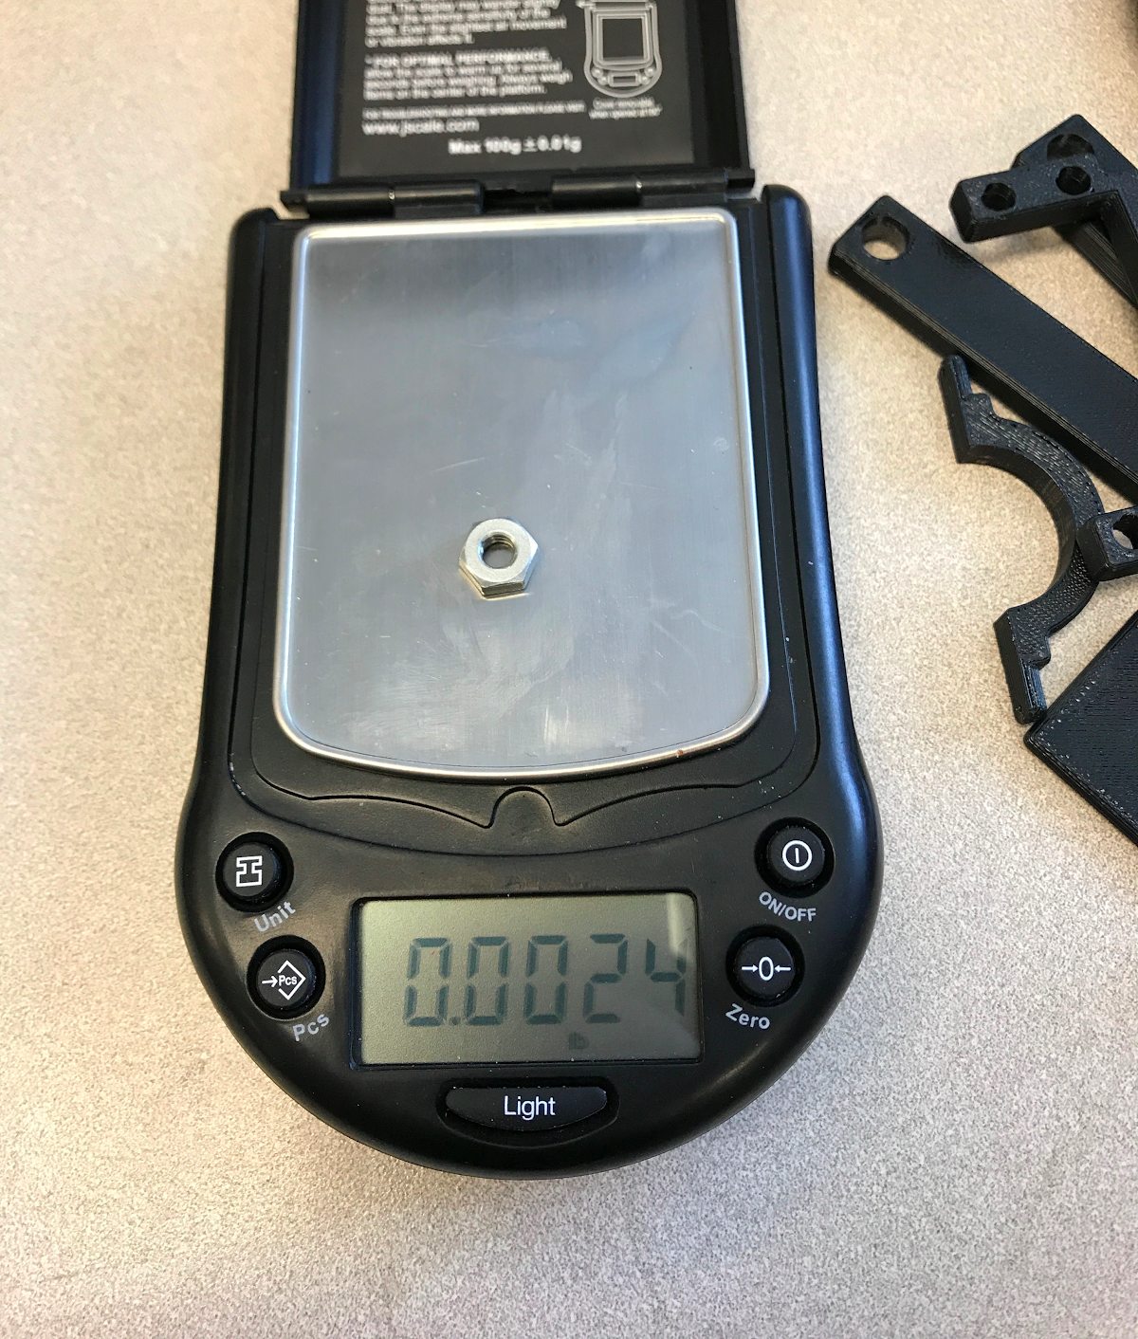
Figure F5: Pivot Base Weight Figure F6: Nut Weight

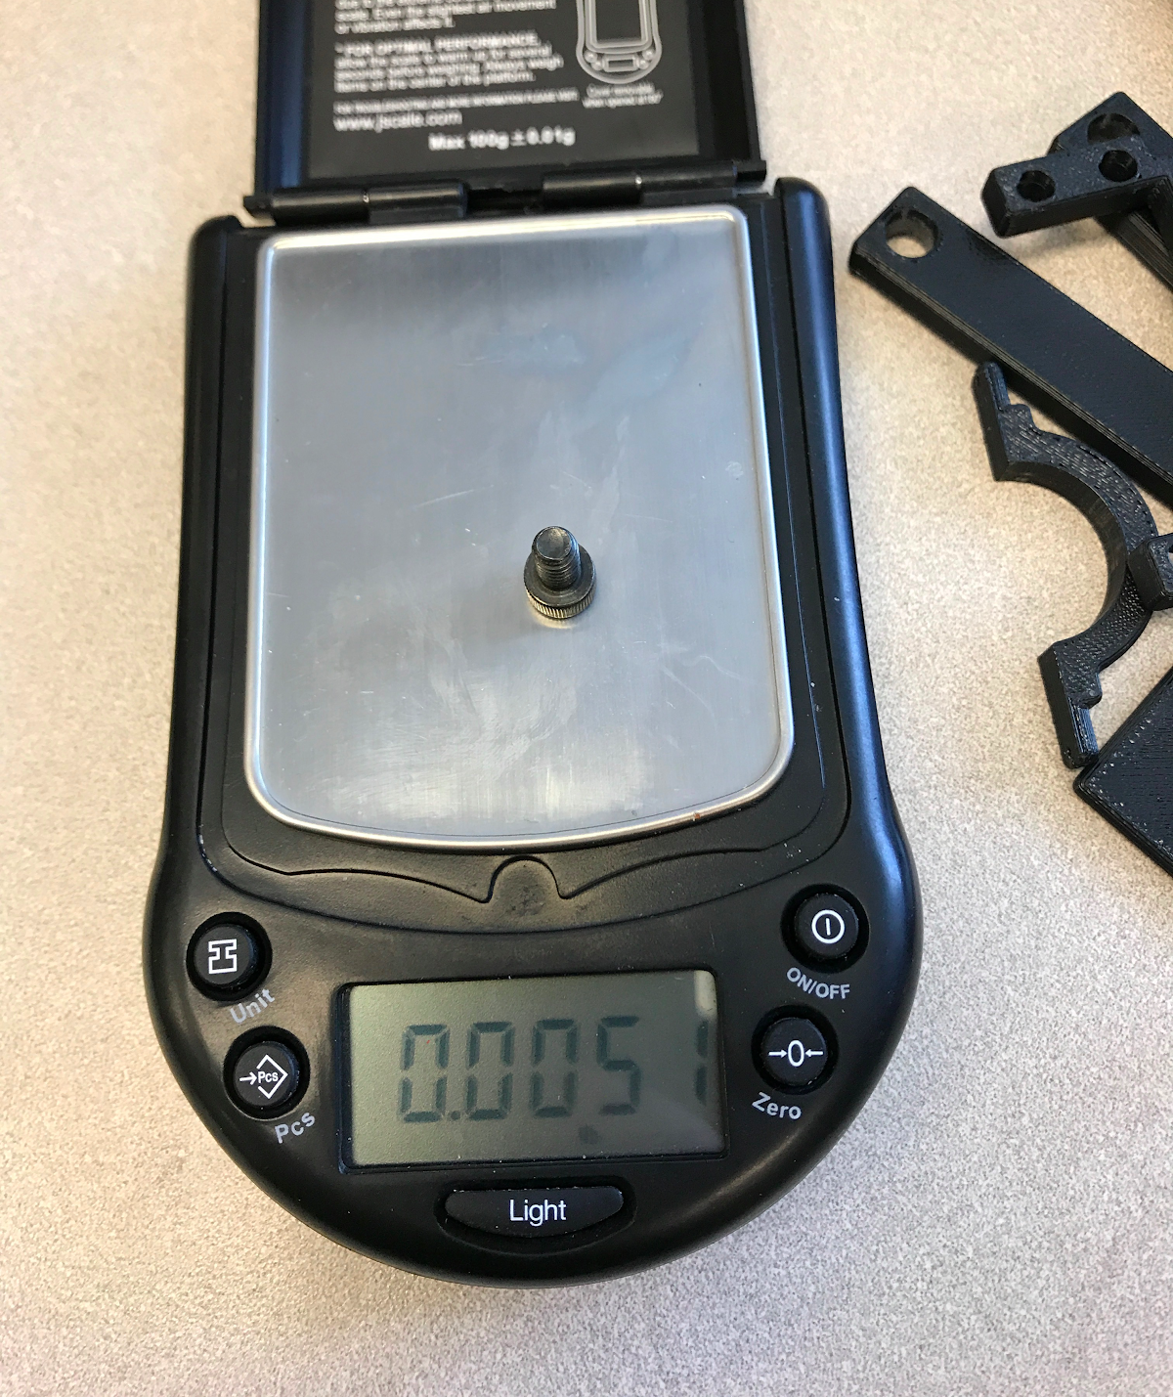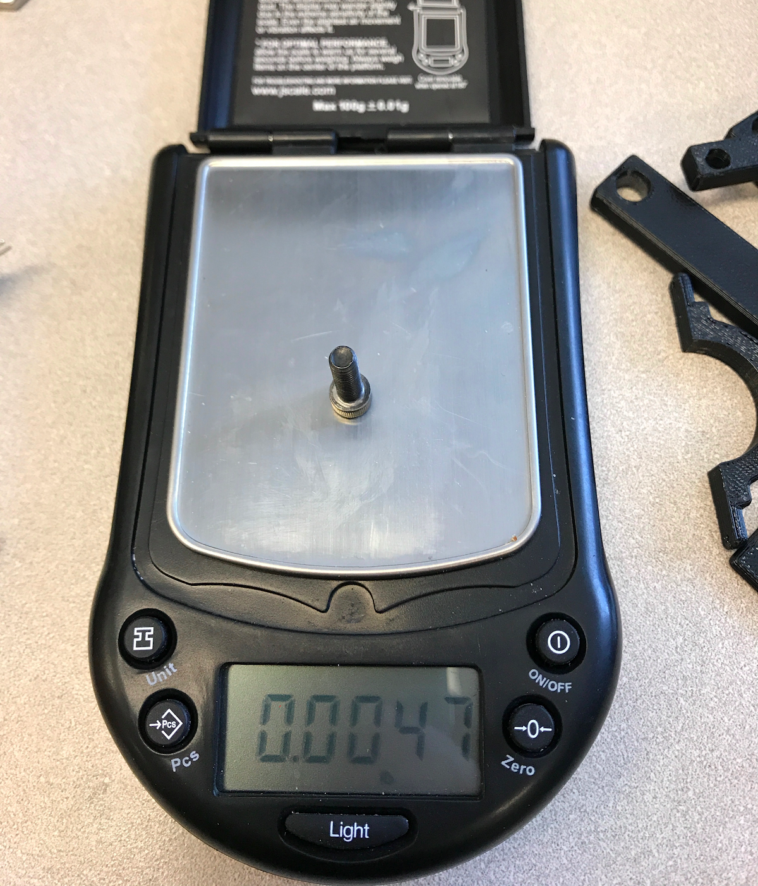
Figure F7: 10-32 Screw Weight Figure F8: M-5 Screw Weight

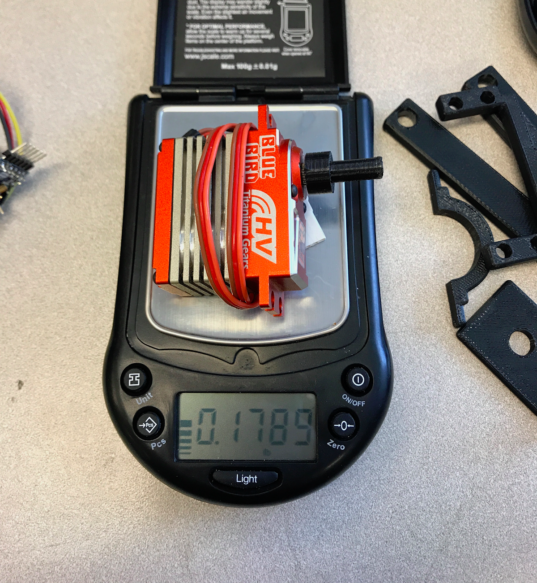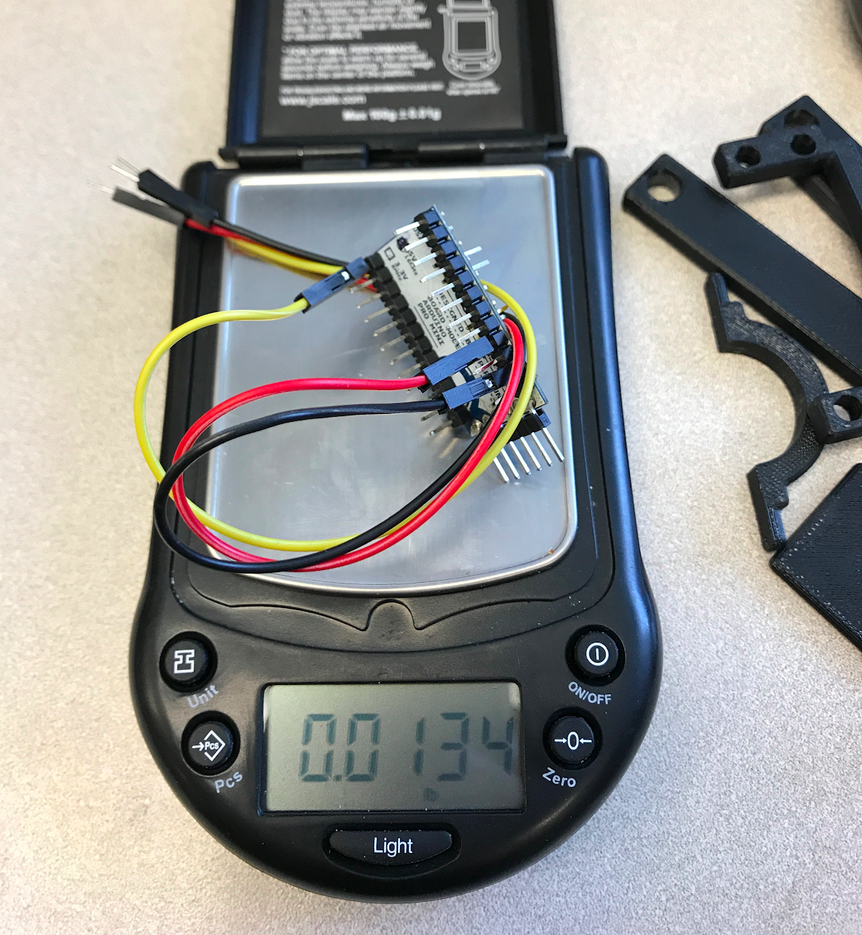
Figure F9: Servo Motor Weight Figure F10: Arduino Pro Mini Weight

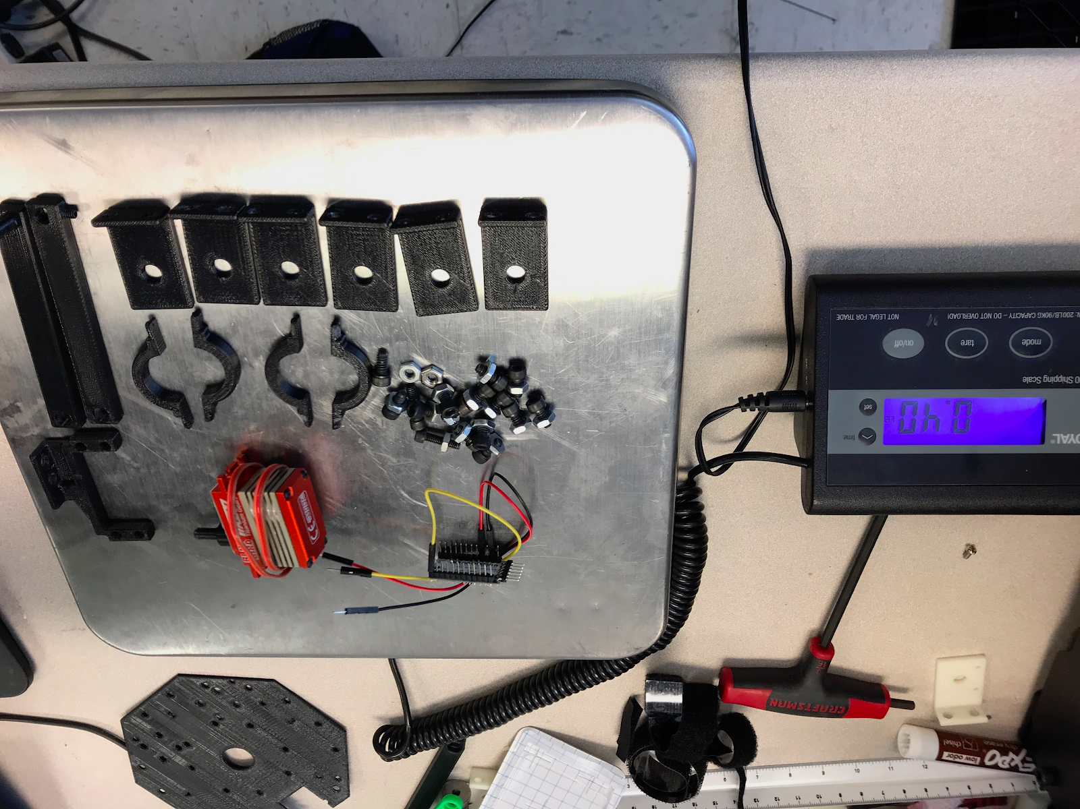
Figure F11: Combined Part Weight

